AKÇAALAN BAĞLANTI ROTASI

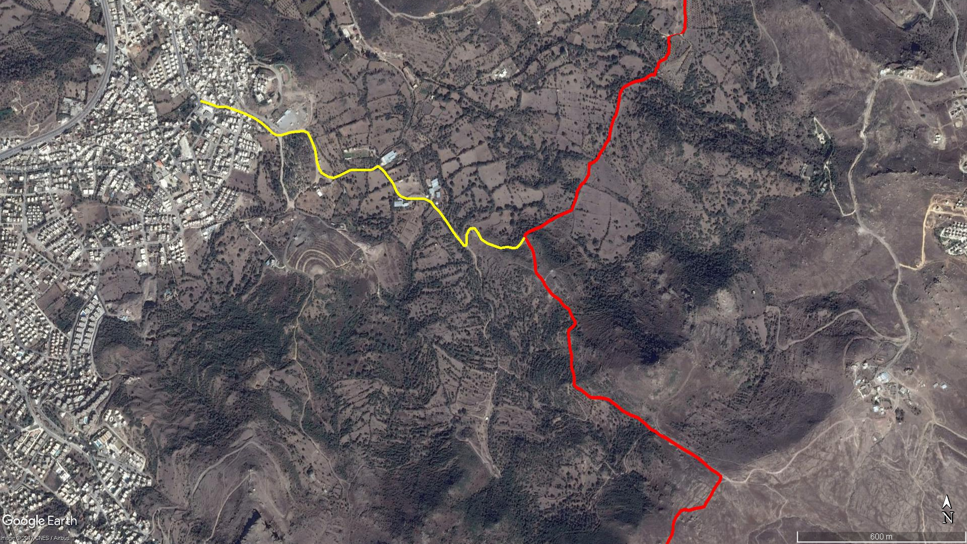
KARABAĞ
Asar Kalesi
Mandıra
AKÇAALAN
BOY KESİT

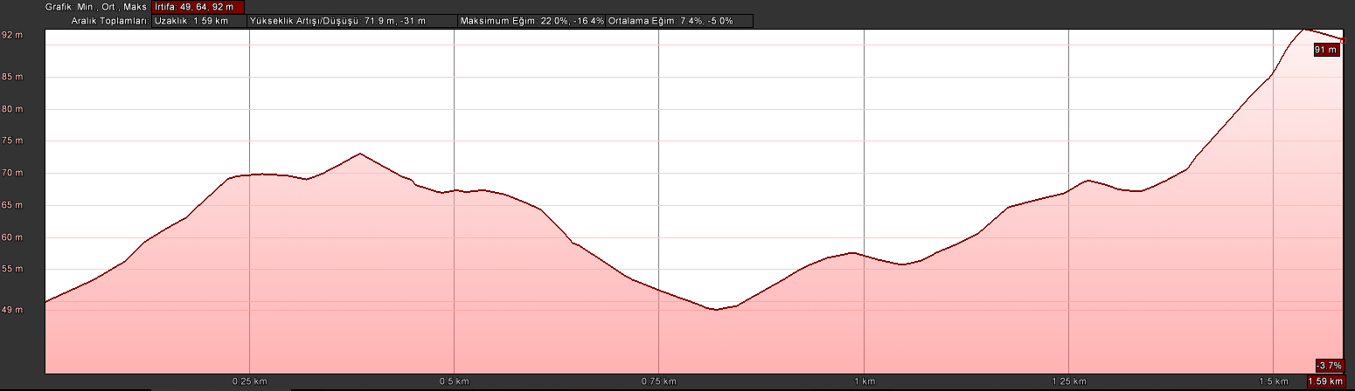
Akçaalan
KOORDİNATLAR
S.NU. | ENLEM | BOYLAM
1 | 37.013280107 | 27.280270910
2 | 37.013184390 | 27.280653446
3 | 37.013080849 | 27.280983659
4 | 37.013092897 | 27.281270038
5 | 37.013017610 | 27.281563268
6 | 37.012903914 | 27.281946573
7 | 37.012727187 | 27.282438321
8 | 37.012582156 | 27.282715559
9 | 37.012408585 | 27.282976342
10 | 37.012239249 | 27.283181463
11 | 37.012177039 | 27.283354887
12 | 37.012180438 | 27.283557197
13 | 37.012271257 | 27.283934521
14 | 37.012308339 | 27.284417184
15 | 37.012254906 | 27.284596462
16 | 37.012042996 | 27.284727864
17 | 37.011744493 | 27.284879182
18 | 37.011592644 | 27.284913751
19 | 37.011327005 | 27.284963773
20 | 37.011118543 | 27.285045575
21 | 37.010966604 | 27.285150677
22 | 37.010848908 | 27.285409681
23 | 37.010807174 | 27.285629272
24 | 37.010902093 | 27.285915657
25 | 37.010972658 | 27.286092567
26 | 37.011058131 | 27.286290489
27 | 37.011065356 | 27.286663486
28 | 37.011059156 | 27.286972446
29 | 37.011078413 | 27.287180537
30 | 37.011188838 | 27.287412113
31 | 37.011033539 | 27.287644569
32 | 37.010865869 | 27.287798403
33 | 37.010650378 | 27.288010494
34 | 37.010369874 | 27.288165602
35 | 37.010223426 | 27.288316265
36 | 37.010136642 | 27.288603243
37 | 37.010151848 | 27.288974060
38 | 37.010138525 | 27.289283472
39 | 37.010040616 | 27.289551155
40 | 37.009897285 | 27.289667025
41 | 37.009757750 | 27.289852245
42 | 37.009586427 | 27.290015454
43 | 37.009358631 | 27.290215268
44 | 37.009161970 | 27.290369753
45 | 37.008958698 | 27.290548434
46 | 37.008739893 | 27.290778321
47 | 37.008633924 | 27.290878077
48 | 37.008645672 | 27.290960681
49 | 37.008804364 | 27.290984655
50 | 37.008969471 | 27.290975627
51 | 37.009118828 | 27.291054263
52 | 37.009195265 | 27.291145227
53 | 37.009191376 | 27.291299781
54 | 37.009049747 | 27.291434110
55 | 37.008846770 | 27.291564564
56 | 37.008710107 | 27.291811691
57 | 37.008617803 | 27.292134050
58 | 37.008560797 | 27.292339451
59 | 37.008596346 | 27.292620225
60 | 37.008556361 | 27.292846359
61 | 37.008574727 | 27.292999666
62 | 37.008691986 | 27.293136004
63 | 37.008896939 | 27.293307234

