ASPAT BAĞLANTI ROTASI
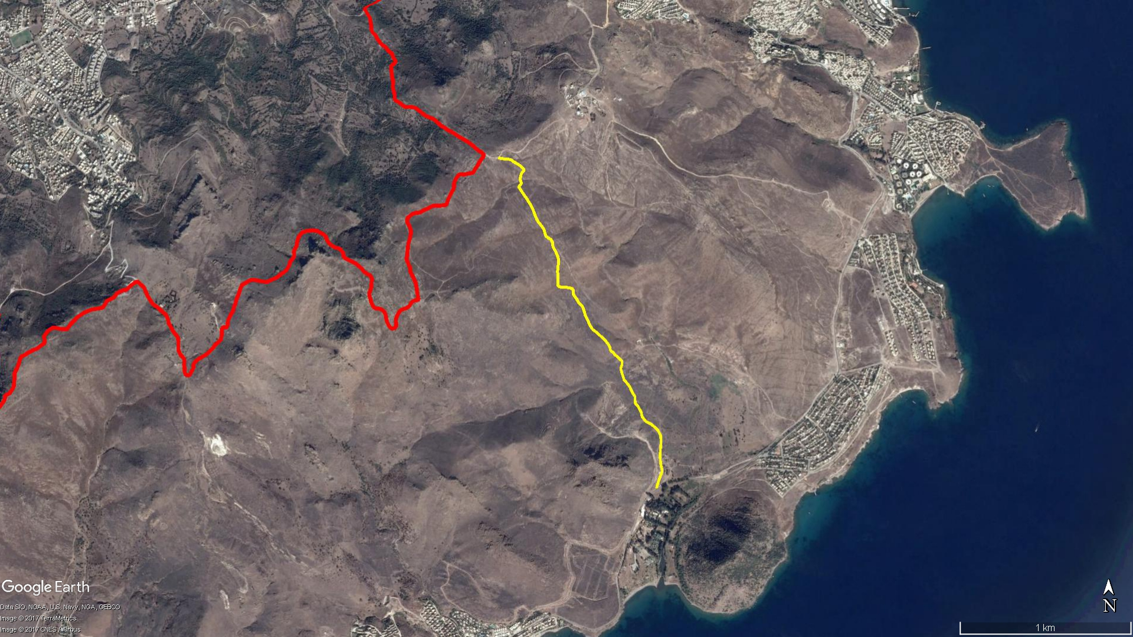
Antik Yol
Aspat
Mandıra
Aspat Kalesi
BAĞLA
Kavakderesi Kamp Alanı
KARABAĞ

BOY KESİT
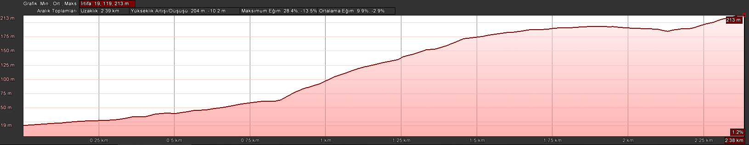
Mandıra
Aspat

KOORDİNATLAR
S.NU | ENLEM | BOYLAM | S.NU | ENLEM | BOYLAM
1 | 36.983895728 | 27.312389981 | 62 | 36.994397875 | 27.306241992
2 | 36.984098017 | 27.312456503 | 63 | 36.994400803 | 27.306117160
3 | 36.984324625 | 27.312547736 | 64 | 36.994445088 | 27.305997044
4 | 36.984569703 | 27.312662191 | 65 | 36.994522411 | 27.305918528
5 | 36.984776209 | 27.312771774 | 66 | 36.994731430 | 27.305927670
6 | 36.985117777 | 27.312676593 | 67 | 36.994891019 | 27.305924417
7 | 36.985415897 | 27.312635329 | 68 | 36.995056910 | 27.305922973
8 | 36.985690839 | 27.312627933 | 69 | 36.995210794 | 27.305906677
9 | 36.985903985 | 27.312646287 | 70 | 36.995380356 | 27.305927122
10 | 36.986221689 | 27.312676438 | 71 | 36.995608999 | 27.305959760
11 | 36.986443126 | 27.312678951 | 72 | 36.995757903 | 27.305981975
12 | 36.986652979 | 27.312655341 | 73 | 36.995866002 | 27.305967317
13 | 36.986936233 | 27.312477103 | 74 | 36.995989262 | 27.305928192
14 | 36.987260300 | 27.312024303 | 75 | 36.996123462 | 27.305850793
15 | 36.987379501 | 27.311694443 | 76 | 36.996280262 | 27.305775012
16 | 36.987644095 | 27.311438845 | 77 | 36.996371239 | 27.305703333
17 | 36.987888503 | 27.311374193 | 78 | 36.996489854 | 27.305619369
18 | 36.988219644 | 27.311139679 | 79 | 36.996612687 | 27.305586575
19 | 36.988342031 | 27.310992914 | 80 | 36.996736736 | 27.305584192
20 | 36.988506816 | 27.310982250 | 81 | 36.996899869 | 27.305452699
21 | 36.988696448 | 27.310969978 | 82 | 36.996968639 | 27.305293593
22 | 36.988868315 | 27.310826076 | 83 | 36.997066783 | 27.305142075
23 | 36.989066957 | 27.310707284 | 84 | 36.997185119 | 27.305094556
24 | 36.989197303 | 27.310629936 | 85 | 36.997384659 | 27.305029601
25 | 36.989386219 | 27.310463289 | 86 | 36.997514529 | 27.304932108
26 | 36.989558197 | 27.310265518 | 87 | 36.997655204 | 27.304795516
27 | 36.989939060 | 27.310110178 | 88 | 36.997812613 | 27.304643751
28 | 36.990161512 | 27.310036224 | 89 | 36.997938873 | 27.304554038
29 | 36.990369184 | 27.310126946 | 90 | 36.998087545 | 27.304471874
30 | 36.990548125 | 27.310131290 | 91 | 36.998240291 | 27.304396415
31 | 36.990645294 | 27.309993401 | 92 | 36.998420892 | 27.304318250
32 | 36.990821105 | 27.309750682 | 93 | 36.998619841 | 27.304201969
33 | 36.990900185 | 27.309627687 | 94 | 36.998779956 | 27.304075190
34 | 36.991017086 | 27.309543718 | 95 | 36.999002284 | 27.303909220
35 | 36.991059222 | 27.309403409 | 96 | 36.999188112 | 27.303737131
36 | 36.991149549 | 27.309352598 | 97 | 36.999380156 | 27.303575593
37 | 36.991223758 | 27.309350131 | 98 | 36.999525007 | 27.303451976
38 | 36.991410319 | 27.309234391 | 99 | 36.999588374 | 27.303395949
39 | 36.991508446 | 27.309145059 | 100 | 36.999665664 | 27.303414348
40 | 36.991678553 | 27.308976166 | 101 | 36.999749611 | 27.303514343
41 | 36.991795901 | 27.308808550 | 102 | 36.999831268 | 27.303549780
42 | 36.991937039 | 27.308603981 | 103 | 36.999931785 | 27.303500002
43 | 36.992059639 | 27.308444034 | 104 | 37.000022385 | 27.303459533
44 | 36.992168595 | 27.308250732 | 105 | 37.000162493 | 27.303506432
45 | 36.992256850 | 27.308146518 | 106 | 37.000278517 | 27.303532868
46 | 36.992492303 | 27.307974994 | 107 | 37.000362505 | 27.303595815
47 | 36.992712695 | 27.307866696 | 108 | 37.000459061 | 27.303704787
48 | 36.992934279 | 27.307722766 | 109 | 37.000529498 | 27.303719483
49 | 36.993134467 | 27.307651464 | 110 | 37.000622586 | 27.303612422
50 | 36.993284152 | 27.307584531 | 111 | 37.000709820 | 27.303485754
51 | 36.993398569 | 27.307527053 | 112 | 37.000788689 | 27.303351606
52 | 36.993509955 | 27.307384925 | 113 | 37.000853224 | 27.303202769
53 | 36.993621496 | 27.307269033 | 114 | 37.000906506 | 27.303079576
54 | 36.993783949 | 27.307156542 | 115 | 37.000963196 | 27.302979026
55 | 36.993956255 | 27.307010417 | 116 | 37.001041903 | 27.302858194
56 | 36.994035311 | 27.306933225 | 117 | 37.001049318 | 27.302696355
57 | 36.994154320 | 27.306936048 | 118 | 37.001052585 | 27.302530310
58 | 36.994268860 | 27.306923245 | 119 | 37.001077300 | 27.302376741
59 | 36.994334850 | 27.306852771 | 120 | 37.001094026 | 27.302250113
60 | 36.994375357 | 27.306640079 | 121 | 37.001104992 | 27.302169910
61 | 36.994405127 | 27.306402430 | 122 | 37.001128707 | 27.302045530

