BODRUM BAĞLANTI ROTASI
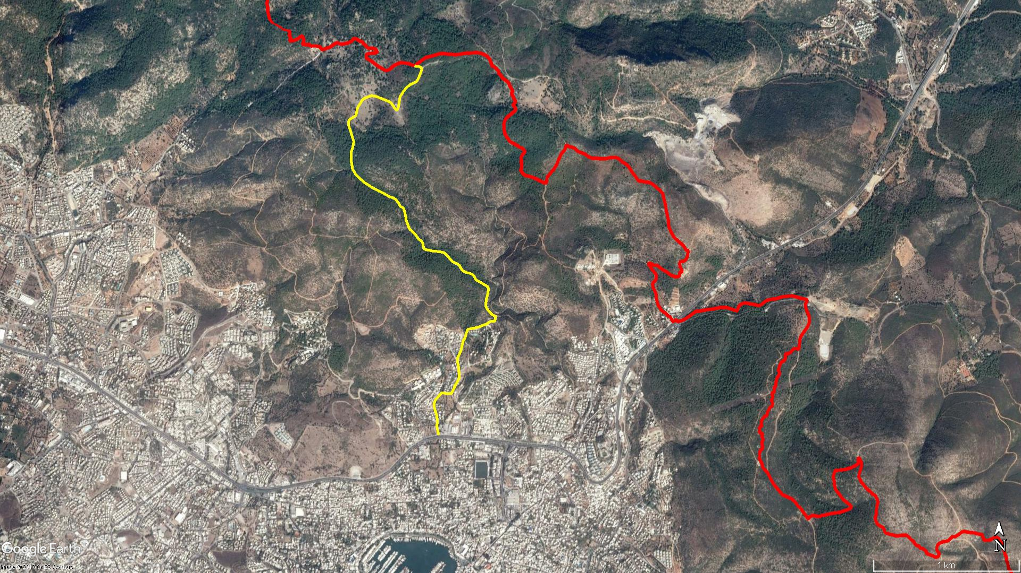
Kışladağı
Yokuşbaşı
Antik
Tiyatro
Pedasa
Pedasa
Kamp Alanı
BODRUM
KONACIK

BOY KESİT
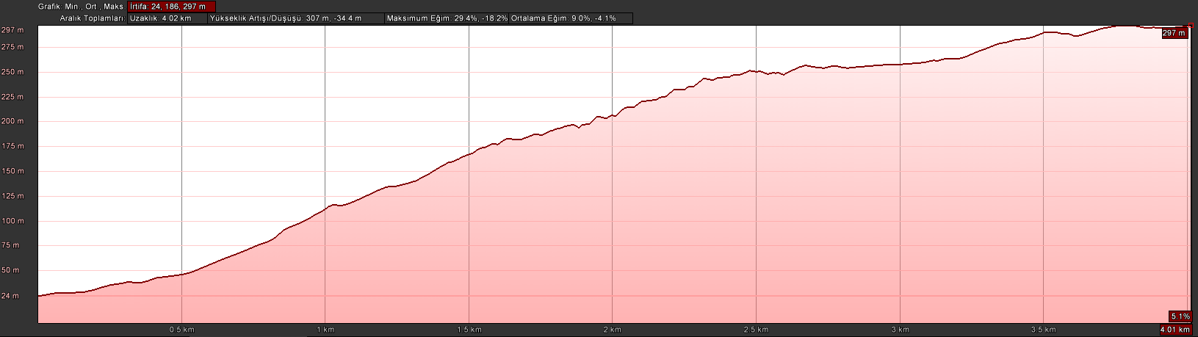
Pedasa
Bodrum

KOORDİNATLAR
S.NU. | ENLEM | BOYLAM | S.NU. | ENLEM | BOYLAM
1 | 37.042411602 | 27.427987157 | 85 | 37.054808696 | 27.426260756
2 | 37.042656310 | 27.427906617 | 86 | 37.054908728 | 27.426130758
3 | 37.042977653 | 27.427835595 | 87 | 37.054995939 | 27.426038574
4 | 37.043264421 | 27.427886385 | 88 | 37.055087805 | 27.425933594
5 | 37.043605184 | 27.427824531 | 89 | 37.055139244 | 27.425816277
6 | 37.044078743 | 27.427654742 | 90 | 37.055249279 | 27.425722607
7 | 37.044354879 | 27.427617878 | 91 | 37.055502871 | 27.425614564
8 | 37.044619181 | 27.427737769 | 92 | 37.055710970 | 27.425506012
9 | 37.044810719 | 27.427961634 | 93 | 37.056011391 | 27.425456018
10 | 37.045018875 | 27.428172966 | 94 | 37.056337078 | 27.425350292
11 | 37.045007761 | 27.428532081 | 95 | 37.056478309 | 27.425293539
12 | 37.044983870 | 27.428967526 | 96 | 37.056601386 | 27.425038377
13 | 37.045221321 | 27.429110048 | 97 | 37.056789462 | 27.424930805
14 | 37.045536662 | 27.429298277 | 98 | 37.056909237 | 27.424793099
15 | 37.045940208 | 27.429570704 | 99 | 37.057028376 | 27.424699438
16 | 37.046284713 | 27.429555090 | 100 | 37.057122545 | 27.424474449
17 | 37.046579959 | 27.429539613 | 101 | 37.057189096 | 27.424195619
18 | 37.046958660 | 27.429447927 | 102 | 37.057332723 | 27.423902599
19 | 37.047146069 | 27.429427922 | 103 | 37.057424331 | 27.423695838
20 | 37.047668983 | 27.429716952 | 104 | 37.057532102 | 27.423405294
21 | 37.048010227 | 27.429805831 | 105 | 37.057636497 | 27.423167579
22 | 37.048237542 | 27.429875013 | 106 | 37.057742266 | 27.422887980
23 | 37.048490352 | 27.430043891 | 107 | 37.057902721 | 27.422601973
24 | 37.048731223 | 27.430120071 | 108 | 37.058017440 | 27.422356142
25 | 37.048980647 | 27.430254708 | 109 | 37.058144636 | 27.422161801
26 | 37.049034406 | 27.430510574 | 110 | 37.058273882 | 27.421979541
27 | 37.049081863 | 27.430875171 | 111 | 37.058412528 | 27.421786913
28 | 37.049149660 | 27.431183974 | 112 | 37.058553804 | 27.421603501
29 | 37.049230304 | 27.431385502 | 113 | 37.058777735 | 27.421470867
30 | 37.049296761 | 27.431672014 | 114 | 37.058865147 | 27.421369086
31 | 37.049432490 | 27.431900041 | 115 | 37.059097499 | 27.421325370
32 | 37.049476929 | 27.432016389 | 116 | 37.059340662 | 27.421276010
33 | 37.049496275 | 27.432336068 | 117 | 37.059625468 | 27.421258840
34 | 37.049777693 | 27.432425094 | 118 | 37.059914913 | 27.421263527
35 | 37.049810045 | 27.432348546 | 119 | 37.060163803 | 27.421361936
36 | 37.049901868 | 27.432135084 | 120 | 37.060430180 | 27.421430500
37 | 37.050062344 | 27.431939391 | 121 | 37.060569218 | 27.421469534
38 | 37.050270802 | 27.431728830 | 122 | 37.060893498 | 27.421336732
39 | 37.050495017 | 27.431634840 | 123 | 37.061208532 | 27.421226766
40 | 37.050837125 | 27.431687883 | 124 | 37.061431616 | 27.421121344
41 | 37.051110432 | 27.431778650 | 125 | 37.061629038 | 27.421049408
42 | 37.051336927 | 27.431828493 | 126 | 37.061771513 | 27.421048256
43 | 37.051545588 | 27.431847716 | 127 | 37.061924919 | 27.421109178
44 | 37.051633005 | 27.431800176 | 128 | 37.062058599 | 27.421371577
45 | 37.051782778 | 27.431489660 | 129 | 37.062166379 | 27.421612568
46 | 37.051915354 | 27.431202993 | 130 | 37.062381394 | 27.421681739
47 | 37.051987916 | 27.431013957 | 131 | 37.062596597 | 27.421740485
48 | 37.052085788 | 27.430861116 | 132 | 37.062780162 | 27.421829711
49 | 37.052208952 | 27.430795018 | 133 | 37.062942160 | 27.421977694
50 | 37.052312132 | 27.430708013 | 134 | 37.063086750 | 27.422081188
51 | 37.052390025 | 27.430616418 | 135 | 37.063204076 | 27.422209178
52 | 37.052463823 | 27.430399286 | 136 | 37.063289484 | 27.422425422
53 | 37.052490098 | 27.430211221 | 137 | 37.063332843 | 27.422566389
54 | 37.052537460 | 27.430088986 | 138 | 37.063404110 | 27.422835183
55 | 37.052582246 | 27.429942283 | 139 | 37.063384710 | 27.423036758
56 | 37.052627215 | 27.429838493 | 140 | 37.063324493 | 27.423325773
57 | 37.052753702 | 27.429736531 | 141 | 37.063253547 | 27.423534632
58 | 37.052877984 | 27.429659554 | 142 | 37.063181101 | 27.423767039
59 | 37.052964096 | 27.429587703 | 143 | 37.063107237 | 27.423993607
60 | 37.053057465 | 27.429421296 | 144 | 37.063029782 | 27.424228096
61 | 37.053091808 | 27.429285908 | 145 | 37.062922622 | 27.424385919
62 | 37.053160672 | 27.429113133 | 146 | 37.062767082 | 27.424523706
63 | 37.053288869 | 27.428952955 | 147 | 37.062623413 | 27.424635562
64 | 37.053360656 | 27.428856221 | 148 | 37.062537956 | 27.424742734
65 | 37.053462272 | 27.428776053 | 149 | 37.062544560 | 27.424831623
66 | 37.053544952 | 27.428658589 | 150 | 37.062707640 | 27.424915057
67 | 37.053646731 | 27.428550621 | 151 | 37.062938006 | 27.424962489
68 | 37.053723968 | 27.428430451 | 152 | 37.063153995 | 27.425001590
69 | 37.053766977 | 27.428292833 | 153 | 37.063324610 | 27.425036495
70 | 37.053792199 | 27.428081746 | 154 | 37.063456358 | 27.425144889
71 | 37.053812200 | 27.427882826 | 155 | 37.063715557 | 27.425344759
72 | 37.053839252 | 27.427649433 | 156 | 37.063909637 | 27.425554092
73 | 37.053843708 | 27.427467854 | 157 | 37.064090353 | 27.425838163
74 | 37.053885361 | 27.427290713 | 158 | 37.064193164 | 27.426120548
75 | 37.053882793 | 27.427151296 | 159 | 37.064278325 | 27.426317683
76 | 37.053920175 | 27.427046897 | 160 | 37.064459909 | 27.426456329
77 | 37.053946432 | 27.426920806 | 161 | 37.064646422 | 27.426546059
78 | 37.054000075 | 27.426844950 | 162 | 37.064873148 | 27.426660009
79 | 37.054200754 | 27.426802326 | 163 | 37.065019570 | 27.426724145
80 | 37.054300607 | 27.426784879 | 164 | 37.065104353 | 27.426687774
81 | 37.054421303 | 27.426708459 | 165 | 37.065186510 | 27.426579948
82 | 37.054490428 | 27.426611357 | 166 | 37.065210460 | 27.426357063
83 | 37.054586501 | 27.426436265 | 167 | 37.065234188 | 27.426157090
84 | 37.054679383 | 27.426358942

