ÇAMLIK BAĞLANTI ROTASI
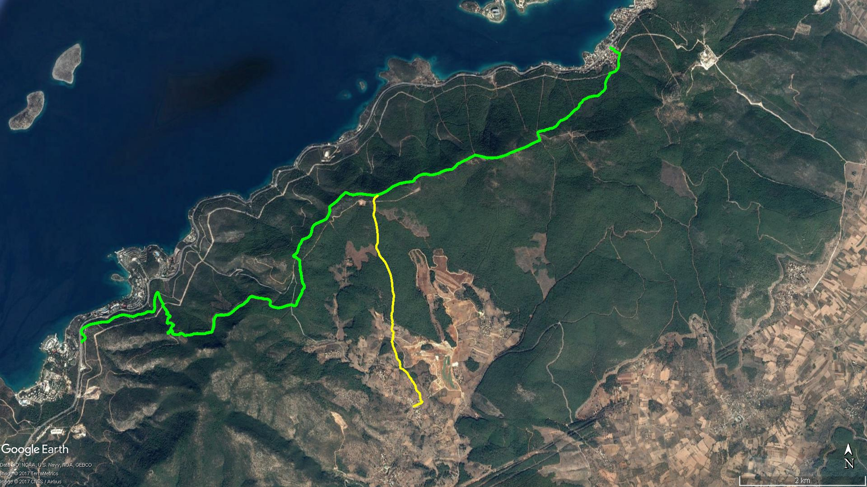
Ömerin Mevkii
TORBA
KAYNAR MEVKİİ
ÇAMLIK
KUMKÖY
İRMENE
GÜVERCİNLİK
Ardıç Dağı
Pamuk Çukuru

BOY KESİT
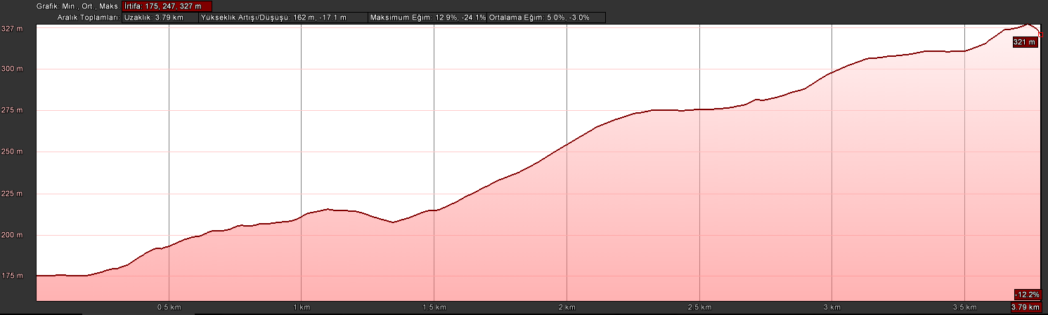
Pamuk Çukuru
Çamlık

KOORDİNATLAR
S.NU | ENLEM | BOYLAM | S.NU | ENLEM | BOYLAM
1 | 37.078762410 | 27.541480319 | 100 | 37.087150050 | 27.537991413
2 | 37.078876564 | 27.541539107 | 101 | 37.087220745 | 27.537970530
3 | 37.078950251 | 27.541765284 | 102 | 37.087280374 | 27.537931701
4 | 37.079064297 | 27.542076529 | 103 | 37.087342888 | 27.537903208
5 | 37.079139824 | 27.542289712 | 104 | 37.087429745 | 27.537867903
6 | 37.079221521 | 27.542505764 | 105 | 37.087470416 | 27.537846062
7 | 37.079251812 | 27.542633708 | 106 | 37.087530036 | 27.537815567
8 | 37.079308710 | 27.542837808 | 107 | 37.087592049 | 27.537813529
9 | 37.079420522 | 27.543013204 | 108 | 37.087644808 | 27.537803592
10 | 37.079529215 | 27.543105916 | 109 | 37.087678033 | 27.537793457
11 | 37.079578117 | 27.543077714 | 110 | 37.087768881 | 27.537759428
12 | 37.079568386 | 27.542988140 | 111 | 37.087804493 | 27.537764522
13 | 37.079567033 | 27.542890174 | 112 | 37.087859102 | 27.537758568
14 | 37.079629447 | 27.542841776 | 113 | 37.087925728 | 27.537744591
15 | 37.079689651 | 27.542777028 | 114 | 37.087993950 | 27.537701301
16 | 37.079692289 | 27.542738457 | 115 | 37.088044726 | 27.537662099
17 | 37.079785712 | 27.542756973 | 116 | 37.088084128 | 27.537637558
18 | 37.079872132 | 27.542764892 | 117 | 37.088135449 | 27.537627368
19 | 37.079977876 | 27.542750968 | 118 | 37.088212052 | 27.537663827
20 | 37.080060460 | 27.542691738 | 119 | 37.088275186 | 27.537708748
21 | 37.080123794 | 27.542655320 | 120 | 37.088367243 | 27.537749437
22 | 37.080198797 | 27.542657413 | 121 | 37.088438474 | 27.537783822
23 | 37.080342772 | 27.542648400 | 122 | 37.088518770 | 27.537822178
24 | 37.080450483 | 27.542701034 | 123 | 37.088592427 | 27.537877132
25 | 37.080529860 | 27.542651409 | 124 | 37.088843054 | 27.537812575
26 | 37.080614711 | 27.542589892 | 125 | 37.088950633 | 27.537853144
27 | 37.080710425 | 27.542584021 | 126 | 37.089019965 | 27.537873692
28 | 37.080760815 | 27.542572261 | 127 | 37.089090592 | 27.537891736
29 | 37.080811550 | 27.542487410 | 128 | 37.089175736 | 27.537894700
30 | 37.080858668 | 27.542392458 | 129 | 37.089254518 | 27.537937951
31 | 37.080894771 | 27.542336552 | 130 | 37.089319904 | 27.537969543
32 | 37.080956338 | 27.542269404 | 131 | 37.089377959 | 27.537975469
33 | 37.080989763 | 27.542214682 | 132 | 37.089453169 | 27.537957197
34 | 37.081033891 | 27.542158906 | 133 | 37.089533171 | 27.537835762
35 | 37.081063617 | 27.542118935 | 134 | 37.089581734 | 27.537733652
36 | 37.081137204 | 27.542084842 | 135 | 37.089653989 | 27.537665877
37 | 37.081201161 | 27.542018996 | 136 | 37.089758711 | 27.537616315
38 | 37.081270053 | 27.541991442 | 137 | 37.089902733 | 27.537621215
39 | 37.081347997 | 27.541949245 | 138 | 37.090479477 | 27.537748560
40 | 37.081416088 | 27.541922040 | 139 | 37.090569935 | 27.537767085
41 | 37.081481516 | 27.541921306 | 140 | 37.090642336 | 27.537766633
42 | 37.081602559 | 27.541925257 | 141 | 37.090716240 | 27.537747060
43 | 37.081724798 | 27.541919824 | 142 | 37.090768078 | 27.537703011
44 | 37.081776310 | 27.541862159 | 143 | 37.090846952 | 27.537689310
45 | 37.081826192 | 27.541812988 | 144 | 37.090935146 | 27.537732721
46 | 37.081888178 | 27.541781563 | 145 | 37.090990004 | 27.537759102
47 | 37.081960318 | 27.541743589 | 146 | 37.091076468 | 27.537750351
48 | 37.082014709 | 27.541683016 | 147 | 37.091182064 | 27.537726725
49 | 37.082083687 | 27.541626358 | 148 | 37.091322671 | 27.537649912
50 | 37.082183134 | 27.541567976 | 149 | 37.091503803 | 27.537645847
51 | 37.082248624 | 27.541508898 | 150 | 37.091625858 | 27.537630758
52 | 37.082317266 | 27.541441954 | 151 | 37.091793550 | 27.537568524
53 | 37.082382453 | 27.541362697 | 152 | 37.092005709 | 27.537594526
54 | 37.082425355 | 27.541320817 | 153 | 37.092146953 | 27.537595620
55 | 37.082476148 | 27.541272858 | 154 | 37.092228272 | 27.537668099
56 | 37.082534299 | 27.541213621 | 155 | 37.092320170 | 27.537746391
57 | 37.082615991 | 27.541159652 | 156 | 37.093042759 | 27.537785235
58 | 37.082696486 | 27.541116330 | 157 | 37.093660232 | 27.537865320
59 | 37.082832202 | 27.541069246 | 158 | 37.094213793 | 27.537979470
60 | 37.082908552 | 27.540988164 | 159 | 37.094777267 | 27.537988779
61 | 37.082978072 | 27.540908540 | 160 | 37.095380754 | 27.537767604
62 | 37.083025556 | 27.540837606 | 161 | 37.095964877 | 27.537737461
63 | 37.083084114 | 27.540776228 | 162 | 37.096482603 | 27.537684141
64 | 37.083164287 | 27.540704857 | 163 | 37.097141898 | 27.537558854
65 | 37.083306953 | 27.540607413 | 164 | 37.097728697 | 27.537383525
66 | 37.083434386 | 27.540547120 | 165 | 37.098300082 | 27.537082530
67 | 37.083474198 | 27.540527271 | 166 | 37.098897803 | 27.536775329
68 | 37.083539719 | 27.540472711 | 167 | 37.099361232 | 27.536511917
69 | 37.083648599 | 27.540405042 | 168 | 37.099867510 | 27.536002298
70 | 37.083732756 | 27.540280003 | 169 | 37.100377557 | 27.535446838
71 | 37.083818346 | 27.540149211 | 170 | 37.100742176 | 27.535326183
72 | 37.083900600 | 27.540057256 | 171 | 37.101060156 | 27.535160522
73 | 37.083965643 | 27.539901993 | 172 | 37.101373250 | 27.534899448
74 | 37.084071347 | 27.539755617 | 173 | 37.101785467 | 27.534872577
75 | 37.084178665 | 27.539597870 | 174 | 37.102165060 | 27.535107411
76 | 37.084288818 | 27.539191560 | 175 | 37.102712647 | 27.535155877
77 | 37.084680242 | 27.539096121 | 176 | 37.103380776 | 27.535104163
78 | 37.084842171 | 27.539118415 | 177 | 37.103892403 | 27.535065885
79 | 37.085194599 | 27.539083029 | 178 | 37.104371572 | 27.534962840
80 | 37.085313014 | 27.538975151 | 179 | 37.104912443 | 27.534867228
81 | 37.085410086 | 27.538889528 | 180 | 37.105364549 | 27.534685709
82 | 37.085505050 | 27.538792882 | 181 | 37.105593925 | 27.534625736
83 | 37.085571897 | 27.538703323 | 182 | 37.105970535 | 27.534442631
84 | 37.085632763 | 27.538626019 | 183 | 37.106317625 | 27.534406347
85 | 37.085713338 | 27.538584426 | 184 | 37.106626893 | 27.534521469
86 | 37.085806466 | 27.538539062 | 185 | 37.106960975 | 27.534595010
87 | 37.086086999 | 27.538468095 | 186 | 37.107169470 | 27.534572415
88 | 37.086315573 | 27.538415965 | 187 | 37.107406842 | 27.534594565
89 | 37.086461471 | 27.538361146 | 188 | 37.107516802 | 27.534596849
90 | 37.086548962 | 27.538293398 | 189 | 37.107754660 | 27.534504334
91 | 37.086637524 | 27.538244184 | 190 | 37.108001294 | 27.534439868
92 | 37.086717379 | 27.538217139 | 191 | 37.108136256 | 27.534432345
93 | 37.086777874 | 27.538183855 | 192 | 37.108320551 | 27.534456134
94 | 37.086817061 | 27.538147559 | 193 | 37.108432115 | 27.534512657
95 | 37.086873423 | 27.538141425 | 194 | 37.108561628 | 27.534613884
96 | 37.086957594 | 27.538113564 | 195 | 37.108695160 | 27.534792530
97 | 37.087019960 | 27.538077402 | 196 | 37.108766781 | 27.534936007
98 | 37.087056923 | 27.538041383 | 197 | 37.108861873 | 27.535107909
99 | 37.087103710 | 27.538020293 | 198 | 37.109000050 | 27.535145985

