ÇİFTLİK BAĞLANTI ROTASI
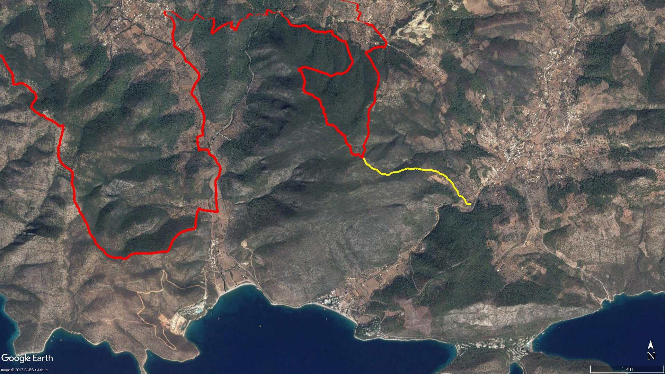
Pınar Dağı
Cin Çukuru
Yatır
Alazeytin
Syangela
Kocadağ
Sea Garden
Çiftlik Yalı
Kamp Alanı
KIZILAĞAÇ
ÇİFTLİK
Taş Ocağı
BOY KESİT
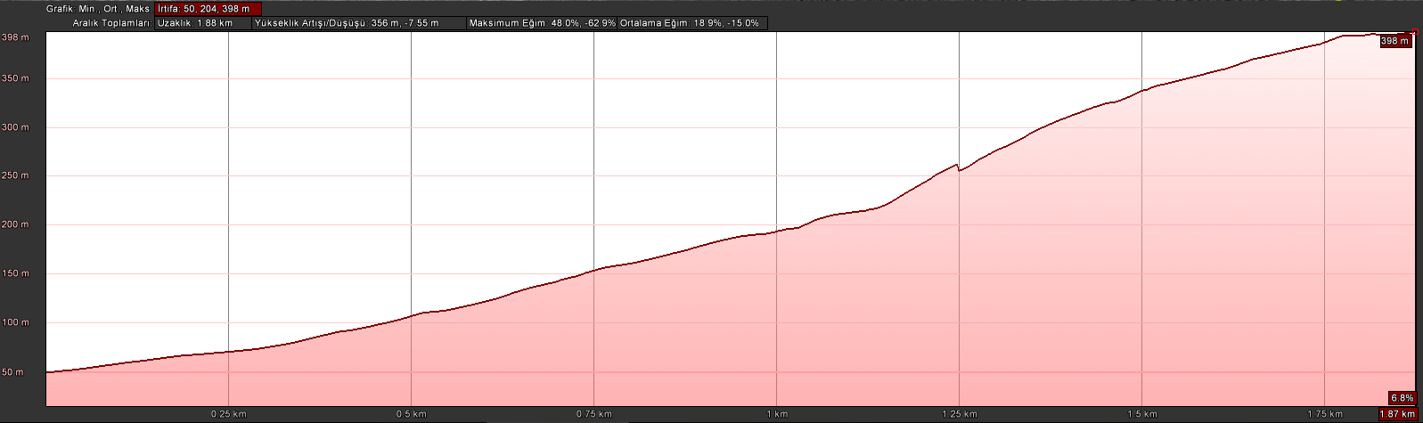
Kocadağ
Yatır

KOORDİNATLAR

S.NU. | ENLEM | BOYLAM |  | S.NU. | ENLEM | BOYLAM
1 | 37.004827041 | 27.551694282 |  | 53 | 37.009125802 | 27.541769839
2 | 37.004849057 | 27.551517414 |  | 54 | 37.009065535 | 27.541515306
3 | 37.004840403 | 27.551306561 |  | 55 | 37.009019365 | 27.541358386
4 | 37.004870496 | 27.551070342 |  | 56 | 37.008967436 | 27.541121980
5 | 37.005070092 | 27.550919150 |  | 57 | 37.008896729 | 27.540962270
6 | 37.005351651 | 27.550803930 |  | 58 | 37.008813876 | 27.540698783
7 | 37.005516461 | 27.550599264 |  | 59 | 37.008769395 | 27.540541775
8 | 37.005719697 | 27.550453553 |  | 60 | 37.008738145 | 27.540271018
9 | 37.005803122 | 27.550202711 |  | 61 | 37.008736095 | 27.540128647
10 | 37.005917296 | 27.549834219 |  | 62 | 37.008730568 | 27.539997086
11 | 37.006199495 | 27.549719146 |  | 63 | 37.008731797 | 27.539842390
12 | 37.006411665 | 27.549658868 |  | 64 | 37.008719067 | 27.539776923
13 | 37.006611867 | 27.549443686 |  | 65 | 37.008684168 | 27.539690379
14 | 37.006811219 | 27.549247425 |  | 66 | 37.008637300 | 27.539561722
15 | 37.006952462 | 27.549111577 |  | 67 | 37.008595039 | 27.539464796
16 | 37.007128004 | 27.549017825 |  | 68 | 37.008553480 | 27.539372326
17 | 37.007364500 | 27.548916074 |  | 69 | 37.008478505 | 27.539276386
18 | 37.007566105 | 27.548651985 |  | 70 | 37.008449550 | 27.539217986
19 | 37.007740169 | 27.548513846 |  | 71 | 37.008417154 | 27.539132800
20 | 37.007848588 | 27.548263134 |  | 72 | 37.008411142 | 27.539053791
21 | 37.007992684 | 27.548083115 |  | 73 | 37.008408047 | 27.538962289
22 | 37.008145371 | 27.548007538 |  | 74 | 37.008423245 | 27.538859614
23 | 37.008281312 | 27.547759375 |  | 75 | 37.008433839 | 27.538763811
24 | 37.008380076 | 27.547547800 |  | 76 | 37.008464976 | 27.538686811
25 | 37.008491880 | 27.547368983 |  | 77 | 37.008523615 | 27.538629813
26 | 37.008515768 | 27.547090400 |  | 78 | 37.008537279 | 27.538530337
27 | 37.008564857 | 27.546929211 |  | 79 | 37.008550709 | 27.538467307
28 | 37.008676141 | 27.546814654 |  | 80 | 37.008487247 | 27.538253100
29 | 37.008749405 | 27.546699316 |  | 81 | 37.008520808 | 27.538198948
30 | 37.008792385 | 27.546594217 |  | 82 | 37.008520660 | 27.538092421
31 | 37.008805011 | 27.546491360 |  | 83 | 37.008589762 | 27.537947552
32 | 37.008891401 | 27.546304749 |  | 84 | 37.008701270 | 27.537772480
33 | 37.008876592 | 27.546078535 |  | 85 | 37.008802932 | 27.537652760
34 | 37.008890176 | 27.545909076 |  | 86 | 37.008931566 | 27.537485858
35 | 37.008970564 | 27.545772256 |  | 87 | 37.009000318 | 27.537409505
36 | 37.009063198 | 27.545582921 |  | 88 | 37.009066658 | 27.537222775
37 | 37.009011452 | 27.545429114 |  | 89 | 37.009097459 | 27.537047972
38 | 37.008993665 | 27.545159876 |  | 90 | 37.009103026 | 27.536865404
39 | 37.008963201 | 27.544929988 |  | 91 | 37.009229251 | 27.536623644
40 | 37.008986604 | 27.544732067 |  | 92 | 37.009341933 | 27.536466441
41 | 37.008999591 | 27.544511686 |  | 93 | 37.009442720 | 27.536301024
42 | 37.009052379 | 27.544222770 |  | 94 | 37.009535048 | 27.536201317
43 | 37.009096956 | 27.543975529 |  | 95 | 37.009617466 | 27.536108365
44 | 37.009152573 | 27.543737309 |  | 96 | 37.009706865 | 27.535776187
45 | 37.009184500 | 27.543575776 |  | 97 | 37.009808644 | 27.535705057
46 | 37.009172728 | 27.543335022 |  | 98 | 37.009939117 | 27.535636982
47 | 37.009195576 | 27.543116553 |  | 99 | 37.010011937 | 27.535553281
48 | 37.009116035 | 27.542835145 |  | 100 | 37.010116648 | 27.535539401
49 | 37.009105836 | 27.542609926 |  | 101 | 37.010261277 | 27.535461654
50 | 37.009140186 | 27.542362803 |  | 102 | 37.010344652 | 27.535378694
51 | 37.009182271 | 27.542118722 |  | 103 | 37.010403818 | 27.535298669
52 | 37.009192687 | 27.541958737 |  | 104 | 37.010446311 | 27.535242342

