ÇİFTLİK (ORTA) BAĞLANTI ROTASI
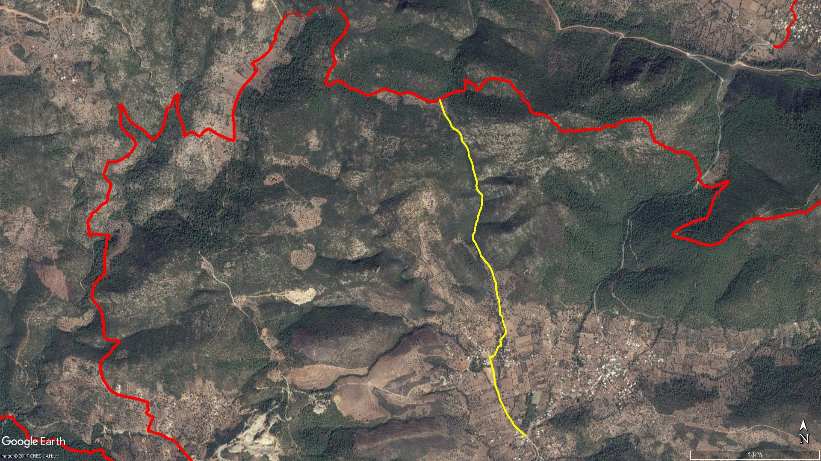
ALAZEYTİN
KÜÇÜK
SARNIÇ
BÜYÜK
SARNIÇ
Kaplan Dağı
Gedikgöl
ÇİFTLİK
(ORTA)
Zeytinli Tarla
Kamp Alanı
ETRİM
BOY KESİT
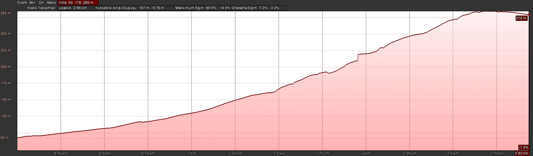
Zeytinli
Tarla
Çiftlik
(Orta)

KOORDİNATLAR
S.NU. | ENLEM | BOYLAM |  | S.NU. | ENLEM | BOYLAM
1 | 37.026865420 | 27.567123115 |  | 56 | 37.041606931 | 27.562793201
2 | 37.027104782 | 27.566773123 |  | 57 | 37.041676512 | 27.562807197
3 | 37.027441399 | 27.566301726 |  | 58 | 37.041725283 | 27.562855040
4 | 37.027620829 | 27.566067466 |  | 59 | 37.041758237 | 27.562892987
5 | 37.027962469 | 27.565840859 |  | 60 | 37.041856550 | 27.562925941
6 | 37.028414820 | 27.565455647 |  | 61 | 37.041948779 | 27.562939089
7 | 37.028737339 | 27.565252289 |  | 62 | 37.041995501 | 27.562937411
8 | 37.029072616 | 27.565072135 |  | 63 | 37.042054791 | 27.562948928
9 | 37.029400527 | 27.564843208 |  | 64 | 37.042118034 | 27.562975295
10 | 37.029775856 | 27.564758829 |  | 65 | 37.042145711 | 27.563011585
11 | 37.030072829 | 27.564590944 |  | 66 | 37.042194453 | 27.563023104
12 | 37.030392521 | 27.564454445 |  | 67 | 37.042239247 | 27.563051128
13 | 37.031017176 | 27.564335392 |  | 68 | 37.042291418 | 27.563047789
14 | 37.031355795 | 27.564302112 |  | 69 | 37.042342789 | 27.563064253
15 | 37.031723135 | 27.564169339 |  | 70 | 37.042390420 | 27.563090860
16 | 37.032091745 | 27.564047481 |  | 71 | 37.042482820 | 27.563109566
17 | 37.032363210 | 27.563952843 |  | 72 | 37.042524753 | 27.563141672
18 | 37.032362350 | 27.564192666 |  | 73 | 37.042551105 | 27.563184556
19 | 37.032483862 | 27.564405896 |  | 74 | 37.042594575 | 27.563217528
20 | 37.032743469 | 27.564536743 |  | 75 | 37.042856856 | 27.563270564
21 | 37.033009046 | 27.564660824 |  | 76 | 37.043011537 | 27.563294639
22 | 37.033103927 | 27.564812981 |  | 77 | 37.043260579 | 27.563298945
23 | 37.033151400 | 27.564971446 |  | 78 | 37.043443939 | 27.563331438
24 | 37.033360078 | 27.564932829 |  | 79 | 37.043614433 | 27.563235272
25 | 37.033508508 | 27.564867630 |  | 80 | 37.043744933 | 27.563035263
26 | 37.033707810 | 27.565091467 |  | 81 | 37.043928460 | 27.562882978
27 | 37.033963404 | 27.565331371 |  | 82 | 37.044190664 | 27.562806106
28 | 37.034179052 | 27.565349963 |  | 83 | 37.044430431 | 27.562872565
29 | 37.034406314 | 27.565292475 |  | 84 | 37.044709205 | 27.562750119
30 | 37.034802405 | 27.565107919 |  | 85 | 37.044978956 | 27.562669802
31 | 37.034983850 | 27.565057411 |  | 86 | 37.045337594 | 27.562517782
32 | 37.035118037 | 27.565050105 |  | 87 | 37.045628327 | 27.562481992
33 | 37.035320821 | 27.564848110 |  | 88 | 37.045953944 | 27.562344097
34 | 37.035492299 | 27.564856872 |  | 89 | 37.046141956 | 27.562207050
35 | 37.035931976 | 27.564800550 |  | 90 | 37.046370719 | 27.562154919
36 | 37.036318615 | 27.564775512 |  | 91 | 37.046577188 | 27.562125215
37 | 37.036560838 | 27.564612656 |  | 92 | 37.046801294 | 27.561998665
38 | 37.036782765 | 27.564597231 |  | 93 | 37.046994683 | 27.561860474
39 | 37.036971004 | 27.564529324 |  | 94 | 37.047155684 | 27.561689878
40 | 37.037401887 | 27.564527240 |  | 95 | 37.047258380 | 27.561581546
41 | 37.037732877 | 27.564354986 |  | 96 | 37.047378850 | 27.561533839
42 | 37.038186014 | 27.564203371 |  | 97 | 37.047554889 | 27.561534736
43 | 37.038451293 | 27.564062352 |  | 98 | 37.047749218 | 27.561443304
44 | 37.038801842 | 27.563782845 |  | 99 | 37.047914281 | 27.561278910
45 | 37.038947657 | 27.563588629 |  | 100 | 37.048044413 | 27.561074961
46 | 37.039116203 | 27.563457304 |  | 101 | 37.048130721 | 27.560863443
47 | 37.039318594 | 27.563220575 |  | 102 | 37.048273145 | 27.560661212
48 | 37.039617550 | 27.563102872 |  | 103 | 37.048478684 | 27.560568794
49 | 37.039911680 | 27.562921396 |  | 104 | 37.048657041 | 27.560472827
50 | 37.040282845 | 27.562686260 |  | 105 | 37.048788868 | 27.560355145
51 | 37.040474792 | 27.562508294 |  | 106 | 37.048932045 | 27.560224000
52 | 37.040792886 | 27.562487548 |  | 107 | 37.049030887 | 27.560114041
53 | 37.040915201 | 27.562632228 |  | 108 | 37.049362013 | 27.559964041
54 | 37.041099434 | 27.562681689 |  | 109 | 37.049561594 | 27.559872956
55 | 37.041328047 | 27.562722176 |  | 110 | 37.050166928 | 27.559630788

