DAĞBELEN BAĞLANTI ROTASI
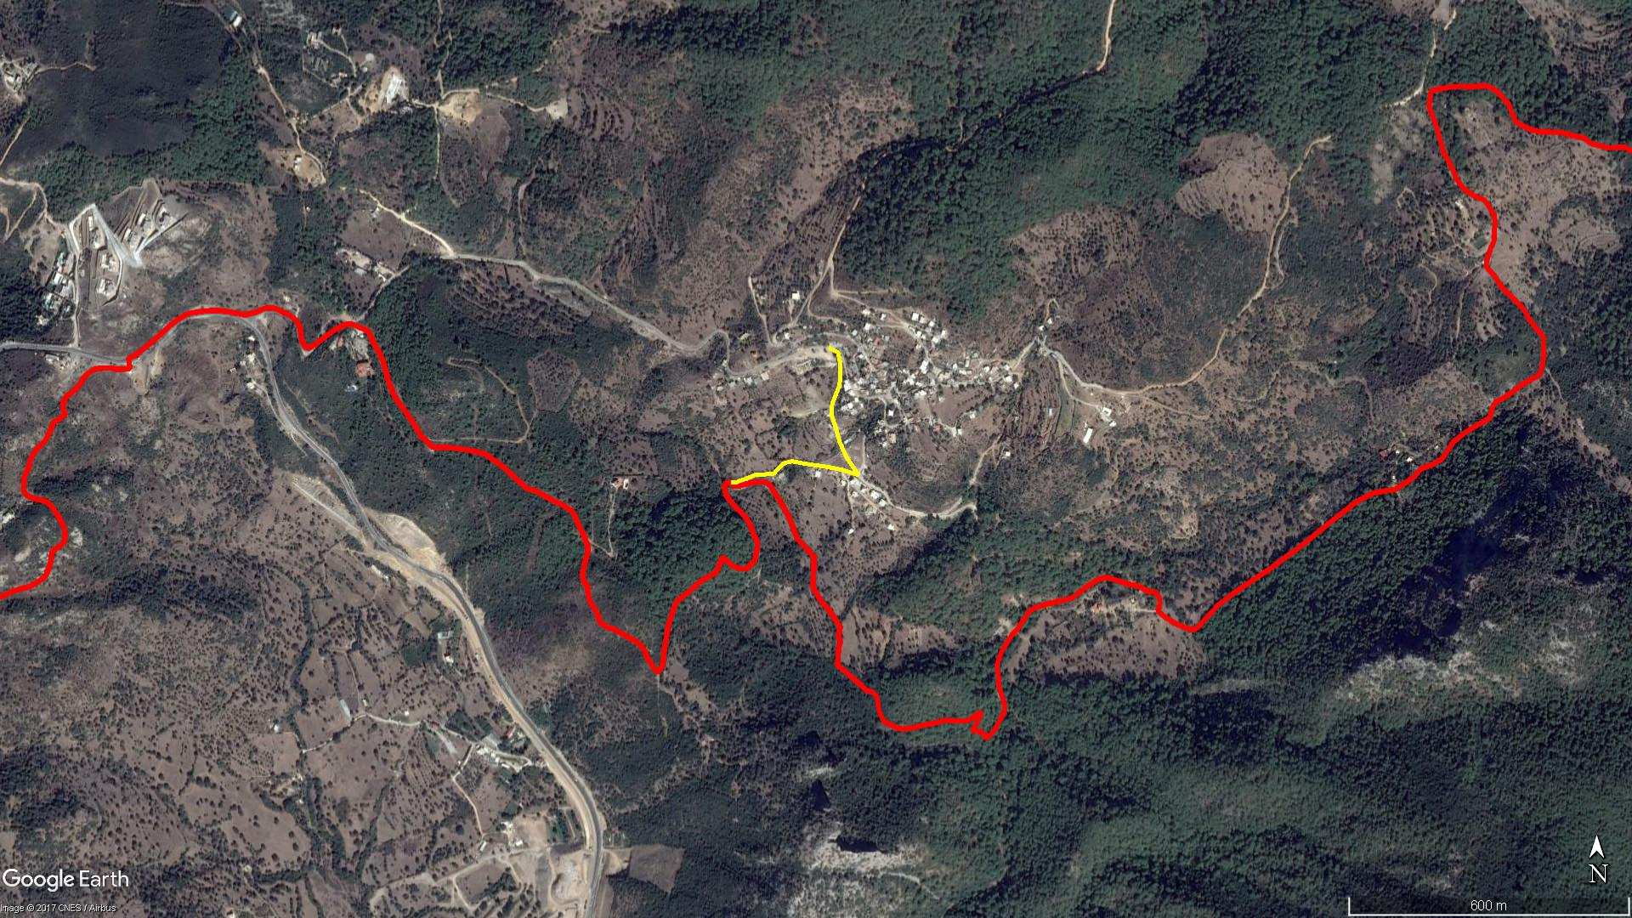
Çobanyurdu
Kamp Alanı
DAĞBELEN

BOY KESİT
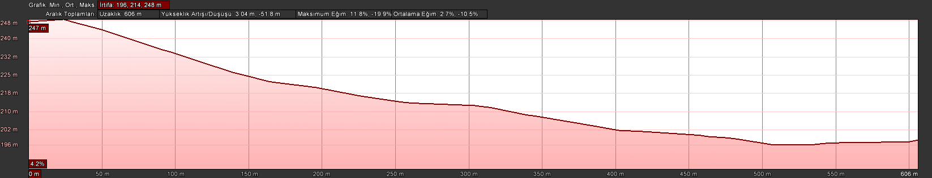
Dağbelen

KOORDİNATLAR
S.NU. | ENLEM | BOYLAM
1 | 37.087778009 | 27.340435208
2 | 37.087685138 | 27.340677640
3 | 37.087453995 | 27.340741942
4 | 37.087044233 | 27.340719776
5 | 37.086687556 | 27.340537922
6 | 37.086467727 | 27.340520996
7 | 37.086239628 | 27.340614946
8 | 37.085937858 | 27.340718471
9 | 37.085647880 | 27.340880390
10 | 37.085287610 | 27.341181520
11 | 37.085390329 | 27.340784491
12 | 37.085454966 | 27.340346994
13 | 37.085504407 | 27.339901181
14 | 37.085556554 | 27.339555755
15 | 37.085526350 | 27.339382619
16 | 37.085488420 | 27.339299039
17 | 37.085314588 | 27.339104251
18 | 37.085300811 | 27.338905877
19 | 37.085297215 | 27.338666852
20 | 37.085239287 | 27.338497610
21 | 37.085186868 | 27.338321945
22 | 37.085146878 | 27.338192038
23 | 37.085137621 | 27.338044284

