ETRİM BAĞLANTI ROTASI
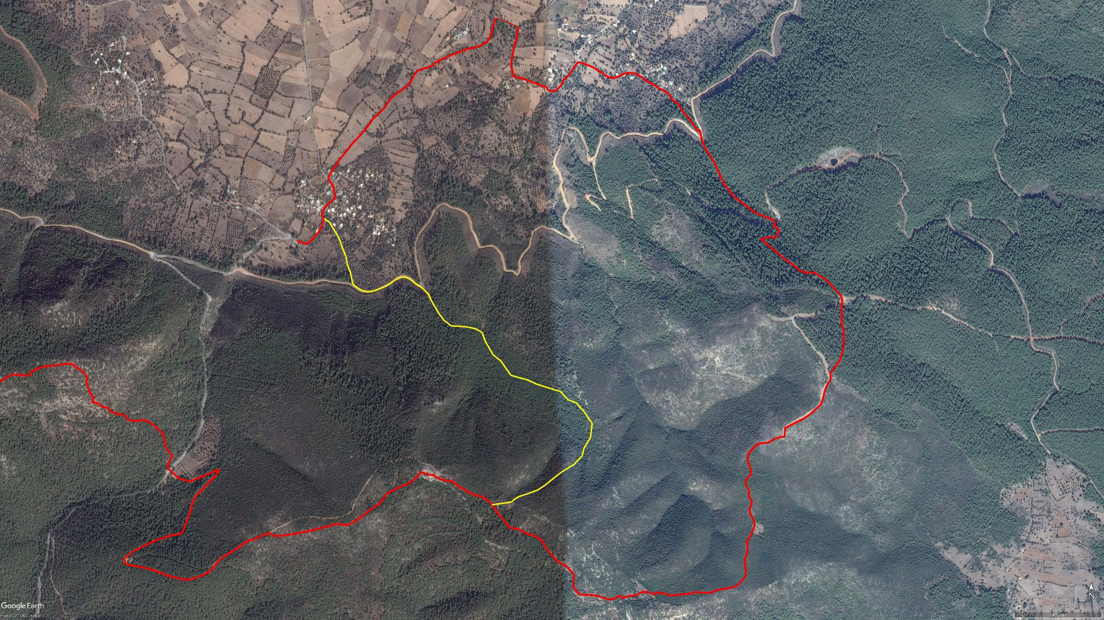
ETRİM
Theangela
BOY KESİT
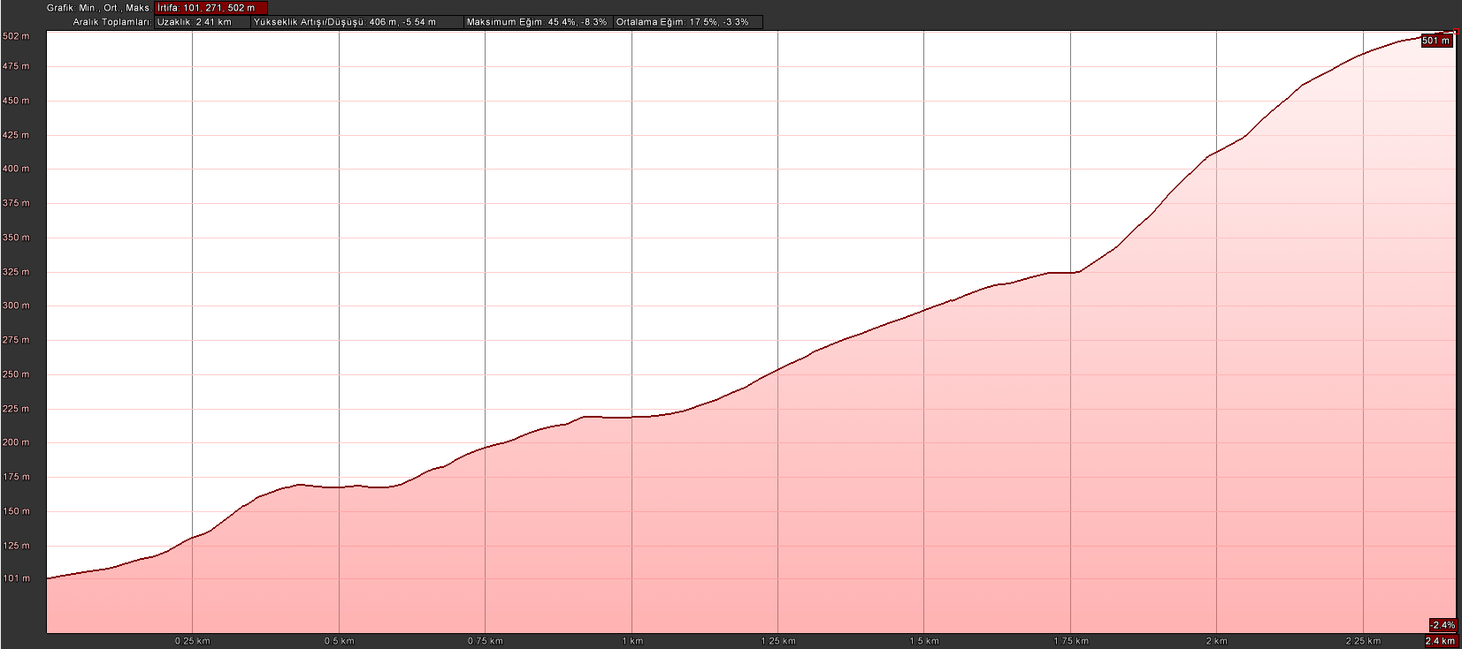
ETRİM
Theangela

KOORDİNATLAR
S.NU. | ENLEM | BOYLAM
1 | 37.054751832 | 27.589861493
2 | 37.054645178 | 27.590112366
3 | 37.053995026 | 27.590620623
4 | 37.053600496 | 27.590792828
5 | 37.053227765 | 27.590985743
6 | 37.052885353 | 27.591064816
7 | 37.052574708 | 27.591223372
8 | 37.052110400 | 27.591351770
9 | 37.051976524 | 27.591557046
10 | 37.051855550 | 27.591826445
11 | 37.051824096 | 27.592001934
12 | 37.051814839 | 27.592254694
13 | 37.051870882 | 27.592528425
14 | 37.051960934 | 27.592802745
15 | 37.052084333 | 27.593115669
16 | 37.052177559 | 27.593299417
17 | 37.052289310 | 27.593476147
18 | 37.052411798 | 27.593787216
19 | 37.052419027 | 27.594009580
20 | 37.052336634 | 27.594246738
21 | 37.052164970 | 27.594517688
22 | 37.052073267 | 27.594711512
23 | 37.051964910 | 27.594897451
24 | 37.051738462 | 27.595195428
25 | 37.051480340 | 27.595344470
26 | 37.051239659 | 27.595510986
27 | 37.050919717 | 27.595760378
28 | 37.050673591 | 27.595995096
29 | 37.050449612 | 27.596367907
30 | 37.050434892 | 27.596742967
31 | 37.050407655 | 27.597212990
32 | 37.050333417 | 27.597615077
33 | 37.050195488 | 27.597936394
34 | 37.049801260 | 27.598121330
35 | 37.049278158 | 27.598514863
36 | 37.049038437 | 27.598906323
37 | 37.048719713 | 27.599183967
38 | 37.048459531 | 27.599423415
39 | 37.048367164 | 27.599814280
40 | 37.048277337 | 27.600258432
41 | 37.048096992 | 27.600760520
42 | 37.047928201 | 27.601439536
43 | 37.047815567 | 27.601939857
44 | 37.047474591 | 27.602338263
45 | 37.047358980 | 27.602748516
46 | 37.047045850 | 27.603115196
47 | 37.046521630 | 27.603574930
48 | 37.045953550 | 27.603492027
49 | 37.045534128 | 27.603179915
50 | 37.045205994 | 27.603073836
51 | 37.044835598 | 27.602643069
52 | 37.044542007 | 27.602037839
53 | 37.044282839 | 27.601625227
54 | 37.043990424 | 27.601182279
55 | 37.043804408 | 27.600834500
56 | 37.043678561 | 27.600418632
57 | 37.043532780 | 27.599882365
58 | 37.043424304 | 27.599660733
59 | 37.043305955 | 27.599495726
60 | 37.043190245 | 27.598507403

