GERİŞ BAĞLANTI ROTASI
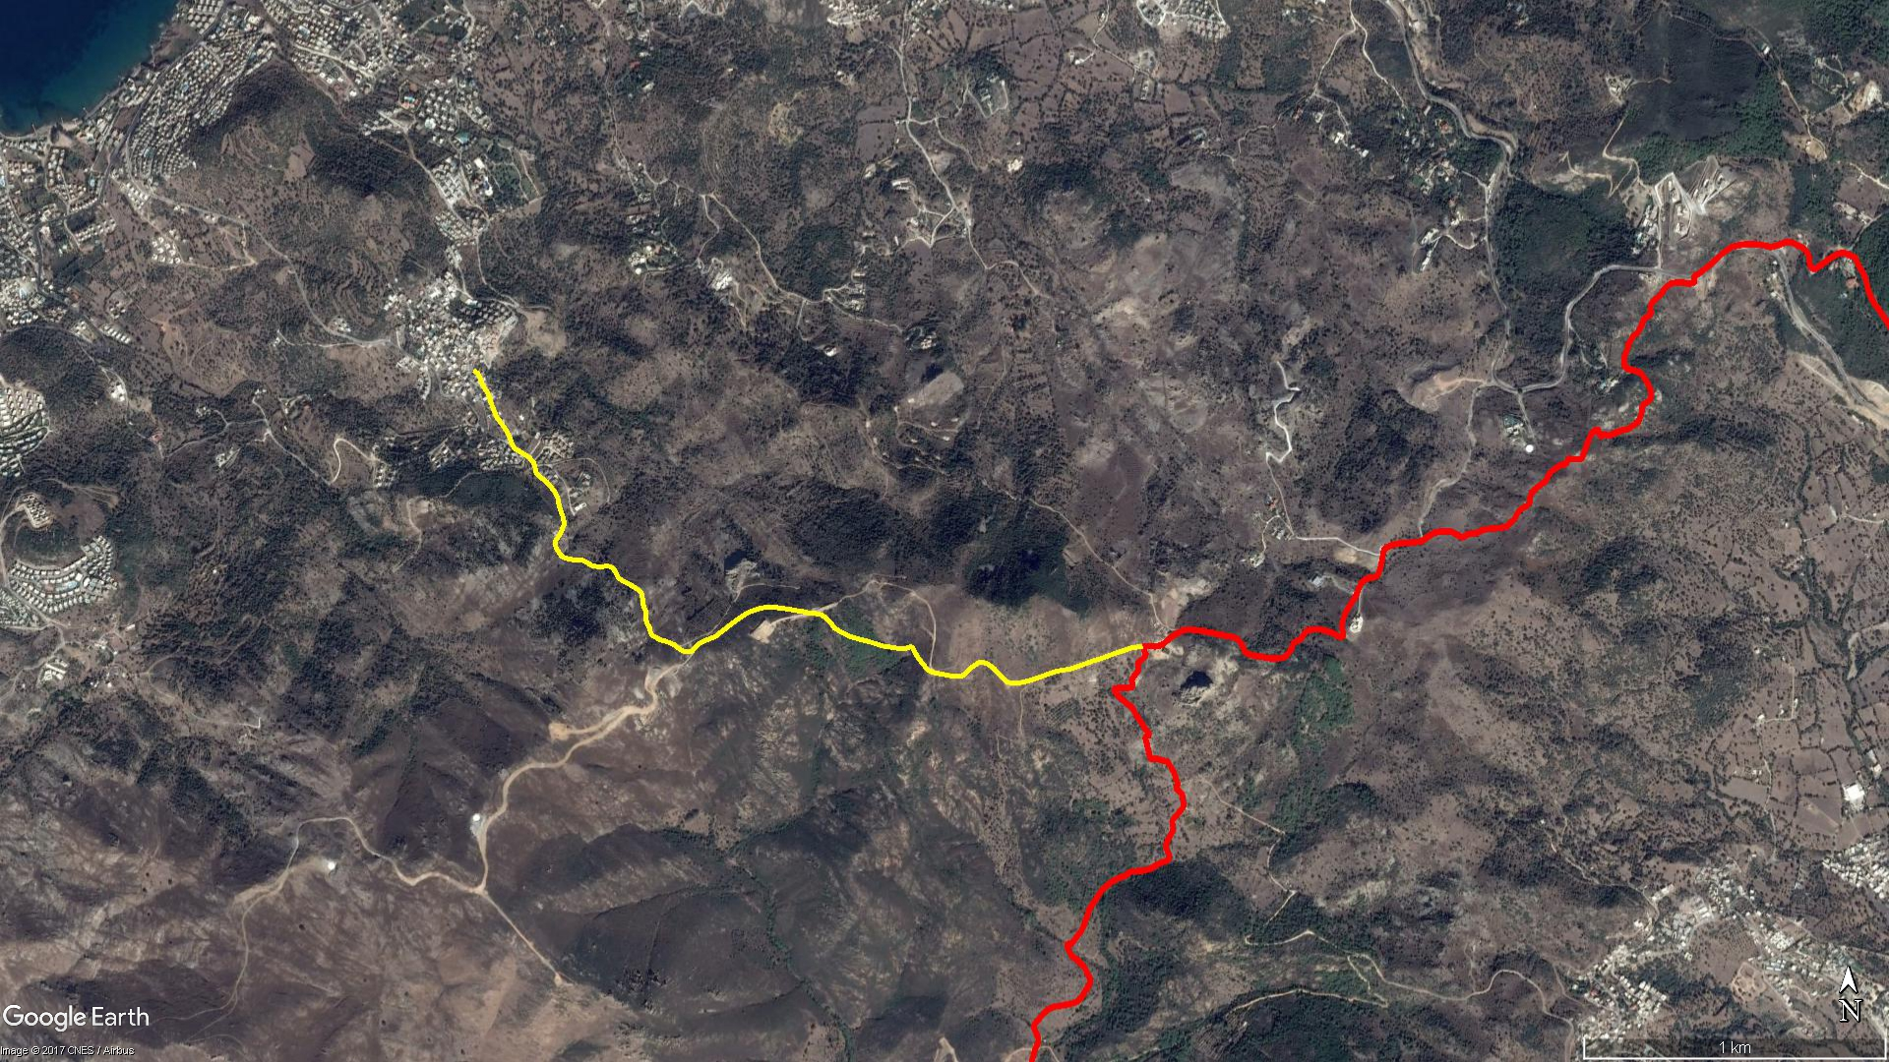
YAKA KÖY
Sandıma
Partipalas
GERİŞ
YALIKAVAK

BOY KESİT
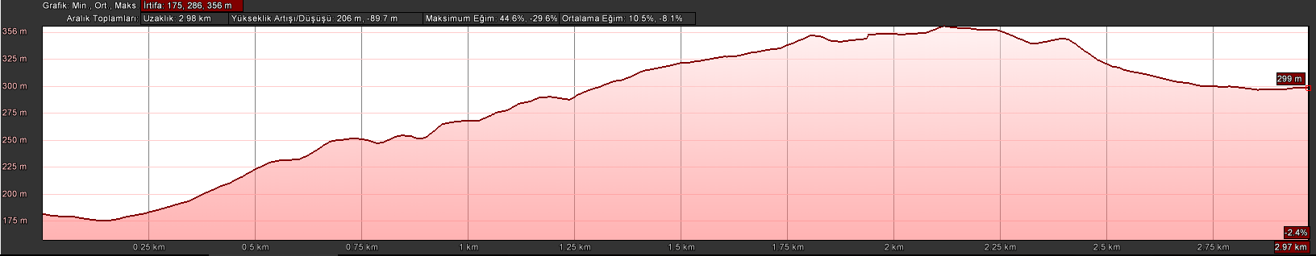
Geriş
Partipalas

KOORDİNATLAR
S.NU | ENLEM | BOYLAM | S.NU | ENLEM | BOYLAM
1 | 37.084829202 | 27.278589440 | 75 | 37.076625956 | 27.286653283
2 | 37.084745776 | 27.278730142 | 76 | 37.076685999 | 27.286721902
3 | 37.084604385 | 27.278837066 | 77 | 37.076778448 | 27.286813945
4 | 37.084445130 | 27.278888653 | 78 | 37.076856926 | 27.286938825
5 | 37.084249179 | 27.279038479 | 79 | 37.076903726 | 27.287059315
6 | 37.084104844 | 27.279146169 | 80 | 37.076969354 | 27.287249475
7 | 37.083862728 | 27.279236473 | 81 | 37.077019512 | 27.287421388
8 | 37.083595977 | 27.279362318 | 82 | 37.077073031 | 27.287548511
9 | 37.083434573 | 27.279453682 | 83 | 37.077160123 | 27.287676727
10 | 37.083258350 | 27.279627528 | 84 | 37.077281359 | 27.287875496
11 | 37.083007016 | 27.279833415 | 85 | 37.077414096 | 27.288095097
12 | 37.082838643 | 27.279931986 | 86 | 37.077535399 | 27.288292519
13 | 37.082696798 | 27.279993070 | 87 | 37.077644587 | 27.288485639
14 | 37.082553395 | 27.280080817 | 88 | 37.077737440 | 27.288682604
15 | 37.082378842 | 27.280427847 | 89 | 37.077809235 | 27.288892206
16 | 37.082268628 | 27.280651589 | 90 | 37.077869773 | 27.289124315
17 | 37.082108802 | 27.280809781 | 91 | 37.077909779 | 27.289391909
18 | 37.081984028 | 27.280861757 | 92 | 37.077905466 | 27.289650940
19 | 37.081837077 | 27.280891103 | 93 | 37.077874081 | 27.289924768
20 | 37.081725683 | 27.281009504 | 94 | 37.077846765 | 27.290192761
21 | 37.081553511 | 27.281295310 | 95 | 37.077805959 | 27.290474538
22 | 37.081433134 | 27.281437930 | 96 | 37.077768282 | 27.290777095
23 | 37.081242090 | 27.281607068 | 97 | 37.077735873 | 27.290899929
24 | 37.081077277 | 27.281708133 | 98 | 37.077735854 | 27.291080053
25 | 37.080869187 | 27.281757016 | 99 | 37.077712067 | 27.291239745
26 | 37.080726684 | 27.281804432 | 100 | 37.077687087 | 27.291367670
27 | 37.080546019 | 27.281894499 | 101 | 37.077580559 | 27.291573846
28 | 37.080339608 | 27.281951604 | 102 | 37.077468289 | 27.291712652
29 | 37.080193621 | 27.281883504 | 103 | 37.077307695 | 27.291842208
30 | 37.080047555 | 27.281802014 | 104 | 37.077204255 | 27.292043245
31 | 37.079974036 | 27.281749267 | 105 | 37.077050752 | 27.292446025
32 | 37.079867603 | 27.281651499 | 106 | 37.076982531 | 27.292731022
33 | 37.079762991 | 27.281623726 | 107 | 37.076907612 | 27.293108657
34 | 37.079635710 | 27.281654919 | 108 | 37.076783254 | 27.293588114
35 | 37.079495422 | 27.281758504 | 109 | 37.076740079 | 27.293957515
36 | 37.079393778 | 27.281857303 | 110 | 37.076697459 | 27.294257257
37 | 37.079337526 | 27.281989316 | 111 | 37.076711009 | 27.294449419
38 | 37.079296333 | 27.282157184 | 112 | 37.076768969 | 27.294673937
39 | 37.079283675 | 27.282327269 | 113 | 37.076588290 | 27.294795181
40 | 37.079287457 | 27.282510920 | 114 | 37.076443758 | 27.294899602
41 | 37.079253035 | 27.282664951 | 115 | 37.076307285 | 27.295030882
42 | 37.079181565 | 27.282825962 | 116 | 37.076166613 | 27.295176774
43 | 37.079109048 | 27.282992854 | 117 | 37.076072572 | 27.295277010
44 | 37.079086668 | 27.283153509 | 118 | 37.076006959 | 27.295463032
45 | 37.079082620 | 27.283383521 | 119 | 37.075971164 | 27.295691871
46 | 37.079107868 | 27.283523118 | 120 | 37.075935402 | 27.295934626
47 | 37.079048579 | 27.283741221 | 121 | 37.075897020 | 27.296172843
48 | 37.078875882 | 27.283862482 | 122 | 37.075888908 | 27.296418811
49 | 37.078742546 | 27.283961713 | 123 | 37.075911577 | 27.296522014
50 | 37.078664690 | 27.284107504 | 124 | 37.076012900 | 27.296664971
51 | 37.078566532 | 27.284355121 | 125 | 37.076123103 | 27.296812718
52 | 37.078444031 | 27.284597995 | 126 | 37.076215946 | 27.296951943
53 | 37.078364264 | 27.284738235 | 127 | 37.076296852 | 27.297121503
54 | 37.078278463 | 27.284805104 | 128 | 37.076306350 | 27.297271572
55 | 37.078095364 | 27.284837464 | 129 | 37.076244384 | 27.297472098
56 | 37.077981099 | 27.284848572 | 130 | 37.076108059 | 27.297689161
57 | 37.077870037 | 27.284902264 | 131 | 37.075934224 | 27.297874601
58 | 37.077762192 | 27.284956904 | 132 | 37.075729824 | 27.298134937
59 | 37.077644276 | 27.284958642 | 133 | 37.075686166 | 27.298368692
60 | 37.077534304 | 27.284953111 | 134 | 37.075698815 | 27.298580523
61 | 37.077402451 | 27.285018388 | 135 | 37.075749111 | 27.298887820
62 | 37.077293725 | 27.285102115 | 136 | 37.075862158 | 27.299329399
63 | 37.077187063 | 27.285124821 | 137 | 37.075943046 | 27.299605911
64 | 37.077098572 | 27.285162988 | 138 | 37.076027181 | 27.299916972
65 | 37.077048335 | 27.285267451 | 139 | 37.076066815 | 27.300143070
66 | 37.076997398 | 27.285369431 | 140 | 37.076097796 | 27.300426429
67 | 37.076948438 | 27.285497707 | 141 | 37.076227884 | 27.300918014
68 | 37.076909428 | 27.285677241 | 142 | 37.076343148 | 27.301308087
69 | 37.076863073 | 27.285836497 | 143 | 37.076426356 | 27.301660658
70 | 37.076810284 | 27.285987296 | 144 | 37.076534160 | 27.302012292
71 | 37.076710764 | 27.286145401 | 145 | 37.076649137 | 27.302445064
72 | 37.076627954 | 27.286316838 | 146 | 37.076724720 | 27.302719540
73 | 37.076597736 | 27.286482281 | 147 | 37.076760126 | 27.303105882
74 | 37.076597876 | 27.286580797

