GÜMÜŞLÜK BAĞLANTI ROTASI
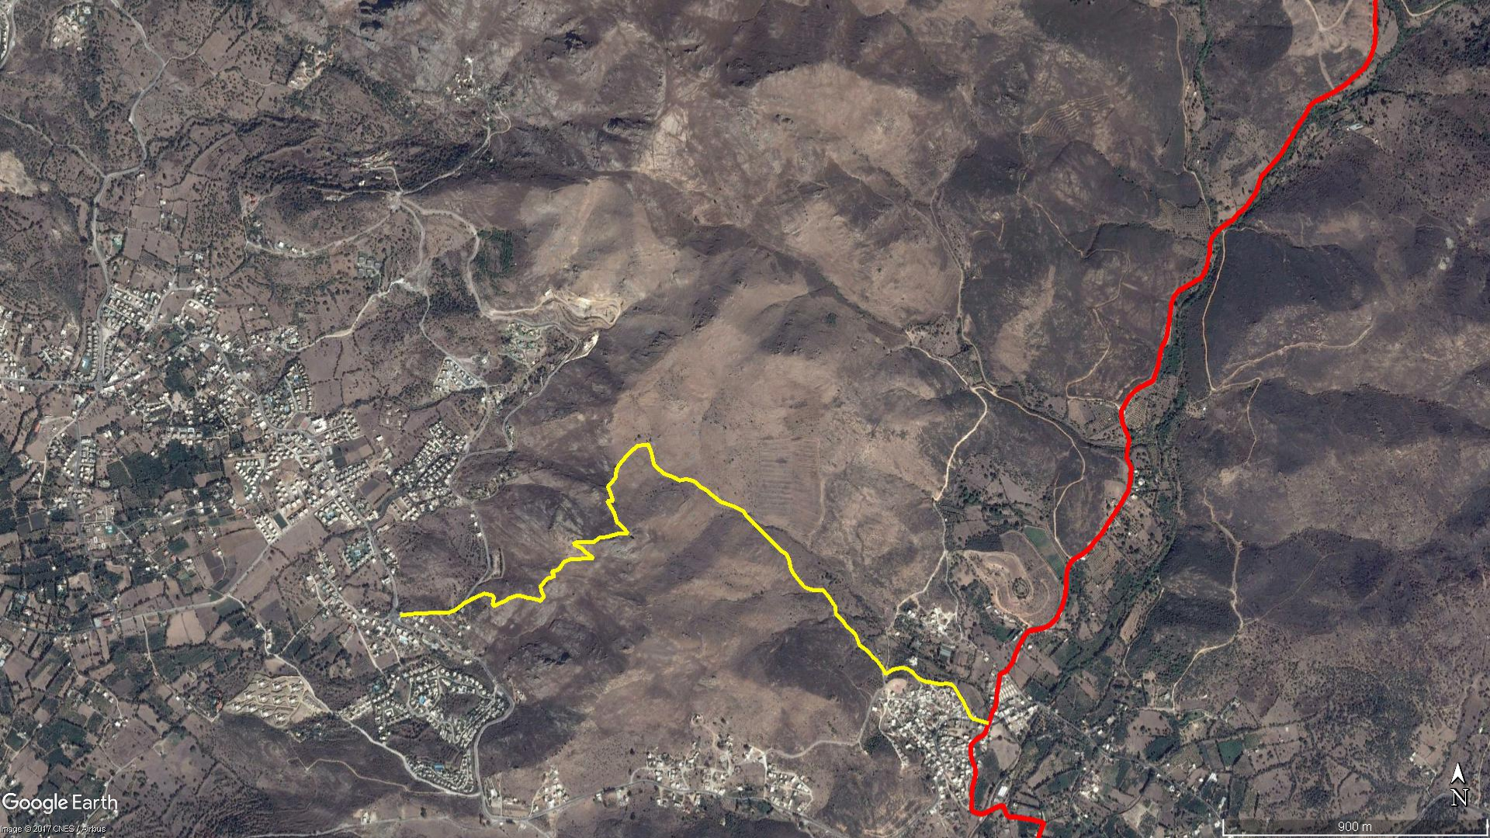
Karakaya
Kavakderesi Kamp Alanı
DEREKÖY
Kayagöl
Karakaya
Kavşağı
GÜMÜŞLÜK

BOY KESİT
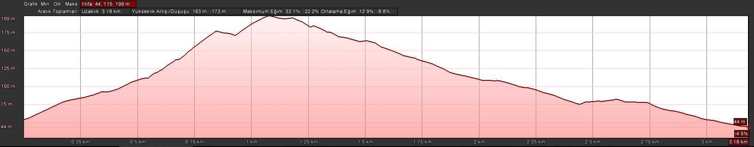
Dereköy
Karakaya
Kavşağı

KOORDİNATLAR
S.NU | ENLEM | BOYLAM | S.NU | ENLEM | BOYLAM
1 | 37.045759894 | 27.261755427 | 83 | 37.050370179 | 27.270170968
2 | 37.045789638 | 27.262026304 | 84 | 37.050651009 | 27.270461917
3 | 37.045823019 | 27.262375860 | 85 | 37.050952767 | 27.270861692
4 | 37.045835682 | 27.262772090 | 86 | 37.050994698 | 27.271279165
5 | 37.045853845 | 27.263204439 | 87 | 37.050752850 | 27.271399072
6 | 37.045861912 | 27.263652644 | 88 | 37.050367279 | 27.271507545
7 | 37.045937922 | 27.263883731 | 89 | 37.050109895 | 27.271868807
8 | 37.046049738 | 27.264076461 | 90 | 37.050044949 | 27.272079773
9 | 37.046145797 | 27.264229019 | 91 | 37.049982024 | 27.272287108
10 | 37.046227920 | 27.264415461 | 92 | 37.049897431 | 27.272478278
11 | 37.046294134 | 27.264577406 | 93 | 37.049927539 | 27.272649025
12 | 37.046358768 | 27.264764335 | 94 | 37.049933921 | 27.272761424
13 | 37.046393625 | 27.264866465 | 95 | 37.049892936 | 27.272943400
14 | 37.046443301 | 27.264990688 | 96 | 37.049857295 | 27.273064142
15 | 37.046409870 | 27.265167881 | 97 | 37.049722934 | 27.273229686
16 | 37.046389224 | 27.265286880 | 98 | 37.049643339 | 27.273400993
17 | 37.046346358 | 27.265354021 | 99 | 37.049583839 | 27.273531929
18 | 37.046263856 | 27.265354138 | 100 | 37.049460234 | 27.273695173
19 | 37.046166642 | 27.265327714 | 101 | 37.049246484 | 27.274043161
20 | 37.046108800 | 27.265316405 | 102 | 37.049166661 | 27.274316214
21 | 37.046065598 | 27.265365775 | 103 | 37.049096149 | 27.274581672
22 | 37.046150616 | 27.265605538 | 104 | 37.048955428 | 27.274909067
23 | 37.046235614 | 27.265831714 | 105 | 37.048789935 | 27.275052895
24 | 37.046282560 | 27.265886517 | 106 | 37.048587813 | 27.275294017
25 | 37.046362767 | 27.266159466 | 107 | 37.048248601 | 27.275727976
26 | 37.046387587 | 27.266305694 | 108 | 37.047972195 | 27.276083624
27 | 37.046350811 | 27.266514196 | 109 | 37.047730718 | 27.276386732
28 | 37.046312624 | 27.266656013 | 110 | 37.047647996 | 27.276557090
29 | 37.046296046 | 27.266861131 | 111 | 37.047458351 | 27.276657880
30 | 37.046254474 | 27.267055641 | 112 | 37.047190220 | 27.276730558
31 | 37.046215259 | 27.267159607 | 113 | 37.047047267 | 27.276831610
32 | 37.046304001 | 27.267233394 | 114 | 37.046895055 | 27.276978215
33 | 37.046331327 | 27.267291559 | 115 | 37.046758558 | 27.277117985
34 | 37.046423797 | 27.267259186 | 116 | 37.046634556 | 27.277258945
35 | 37.046495393 | 27.267198910 | 117 | 37.046555643 | 27.277539433
36 | 37.046519978 | 27.267194948 | 118 | 37.046552988 | 27.277722878
37 | 37.046642390 | 27.267164976 | 119 | 37.046539148 | 27.277965788
38 | 37.046682594 | 27.267164025 | 120 | 37.046337240 | 27.278177210
39 | 37.046756577 | 27.267254206 | 121 | 37.046159018 | 27.278326803
40 | 37.046915126 | 27.267440564 | 122 | 37.046035563 | 27.278433347
41 | 37.046947908 | 27.267589630 | 123 | 37.045926040 | 27.278433729
42 | 37.046988208 | 27.267699082 | 124 | 37.045793317 | 27.278468692
43 | 37.047048691 | 27.267642994 | 125 | 37.045685139 | 27.278618295
44 | 37.047126964 | 27.267600146 | 126 | 37.045612097 | 27.278710414
45 | 37.047145022 | 27.267698662 | 127 | 37.045434737 | 27.278859171
46 | 37.047172108 | 27.267824409 | 128 | 37.045360555 | 27.278978489
47 | 37.047212898 | 27.267887541 | 129 | 37.045190122 | 27.279200198
48 | 37.047270768 | 27.267940159 | 130 | 37.045009677 | 27.279289535
49 | 37.047320948 | 27.267976612 | 131 | 37.044865578 | 27.279347277
50 | 37.047396931 | 27.268035576 | 132 | 37.044769518 | 27.279525974
51 | 37.047433615 | 27.268101182 | 133 | 37.044661906 | 27.279697633
52 | 37.047461031 | 27.268189558 | 134 | 37.044500142 | 27.279860758
53 | 37.047499929 | 27.268328449 | 135 | 37.044390896 | 27.280023989
54 | 37.047504679 | 27.268434182 | 136 | 37.044146146 | 27.280250025
55 | 37.047506640 | 27.268528316 | 137 | 37.043988335 | 27.280355720
56 | 37.047503245 | 27.268657288 | 138 | 37.044047782 | 27.280497277
57 | 37.047522291 | 27.268748030 | 139 | 37.044118586 | 27.280627758
58 | 37.047533010 | 27.268817942 | 140 | 37.044172839 | 27.280973297
59 | 37.047544026 | 27.268871086 | 141 | 37.044140924 | 27.281166910
60 | 37.047533996 | 27.268989337 | 142 | 37.044058267 | 27.281356975
61 | 37.047541207 | 27.269198095 | 143 | 37.043873617 | 27.281576318
62 | 37.047727807 | 27.268877889 | 144 | 37.043818814 | 27.281672923
63 | 37.047860539 | 27.268702559 | 145 | 37.043748518 | 27.281881183
64 | 37.047963082 | 27.268429065 | 146 | 37.043736326 | 27.282040159
65 | 37.048008062 | 27.268499089 | 147 | 37.043660829 | 27.282441740
66 | 37.048027599 | 27.268591582 | 148 | 37.043679940 | 27.282614290
67 | 37.048027440 | 27.268768939 | 149 | 37.043680347 | 27.282726739
68 | 37.048038185 | 27.269018490 | 150 | 37.043658537 | 27.282877124
69 | 37.048022307 | 27.269194964 | 151 | 37.043573240 | 27.282995259
70 | 37.048171425 | 27.269445691 | 152 | 37.043416568 | 27.283115341
71 | 37.048189892 | 27.269731346 | 153 | 37.043319164 | 27.283182686
72 | 37.048283735 | 27.270134515 | 154 | 37.043202893 | 27.283277989
73 | 37.048292558 | 27.270512340 | 155 | 37.043130972 | 27.283346234
74 | 37.048496725 | 27.270308950 | 156 | 37.042990557 | 27.283416051
75 | 37.048643606 | 27.270088535 | 157 | 37.042910260 | 27.283475557
76 | 37.048909410 | 27.269993740 | 158 | 37.042677828 | 27.283607865
77 | 37.049279006 | 27.269716866 | 159 | 37.042591557 | 27.283717269
78 | 37.049269724 | 27.269944607 | 160 | 37.042569605 | 27.283875569
79 | 37.049413604 | 27.269891280 | 161 | 37.042529237 | 27.284031354
80 | 37.049712702 | 27.269747117 | 162 | 37.042486901 | 27.284192072
81 | 37.049976129 | 27.270029819 | 163 | 37.042473961 | 27.284322422
82 | 37.050236674 | 27.270074413

