GÜRECE BAĞLANTI ROTASI
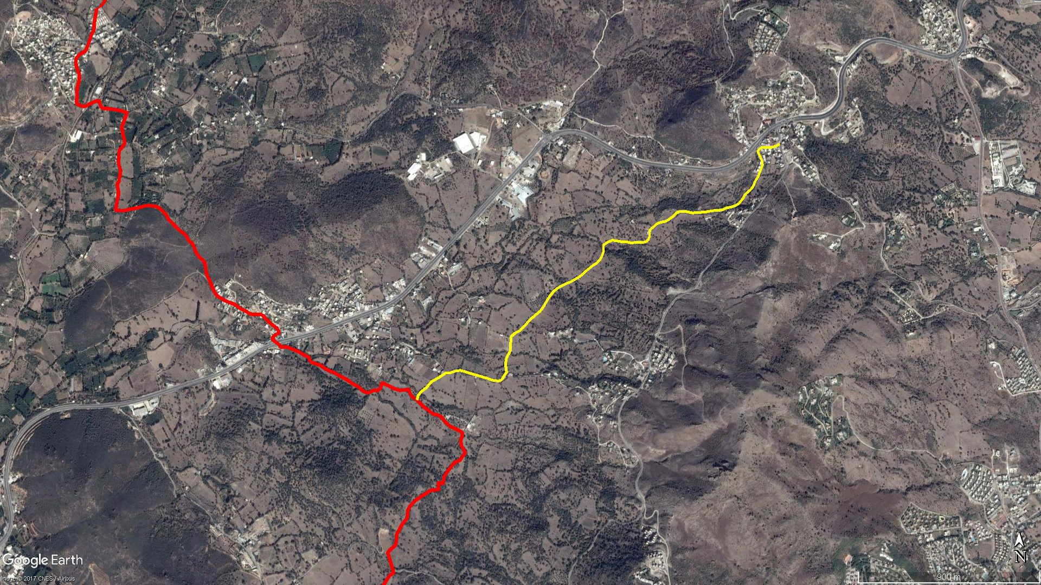
Mezarlık
YAHŞİ
GÜRECE
İSLAMHANELERİ
DEREKÖY

BOY KESİT
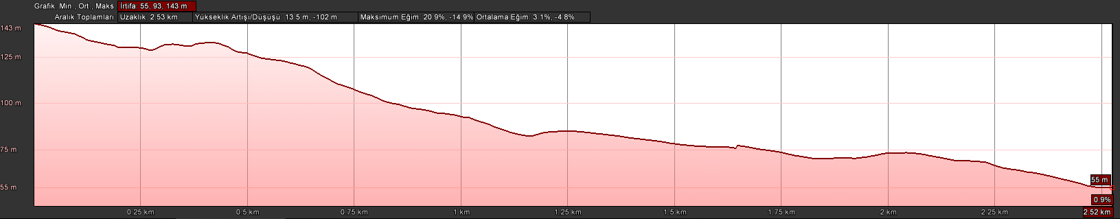
Mezarlık
Gürece

KOORDİNATLAR
S.NU | ENLEM | BOYLAM | S.NU | ENLEM | BOYLAM
1 | 37.038018372 | 27.322226591 | 62 | 37.032433850 | 27.311584350
2 | 37.037909054 | 27.321948218 | 63 | 37.032282359 | 27.311391008
3 | 37.037865427 | 27.321732703 | 64 | 37.032196242 | 27.311240421
4 | 37.037860832 | 27.321460433 | 65 | 37.032092839 | 27.311010246
5 | 37.037872041 | 27.321233935 | 66 | 37.031995324 | 27.310804022
6 | 37.037802972 | 27.321133290 | 67 | 37.031921935 | 27.310551963
7 | 37.037734979 | 27.321053246 | 68 | 37.031799415 | 27.310254820
8 | 37.037657168 | 27.321040351 | 69 | 37.031712386 | 27.310069264
9 | 37.037487439 | 27.321154471 | 70 | 37.031570974 | 27.309862003
10 | 37.037267732 | 27.321261482 | 71 | 37.031394980 | 27.309679468
11 | 37.037109686 | 27.321298125 | 72 | 37.031258534 | 27.309570554
12 | 37.036790808 | 27.321141117 | 73 | 37.031100058 | 27.309444926
13 | 37.036586674 | 27.321046898 | 74 | 37.030898938 | 27.309303656
14 | 37.036414587 | 27.320904973 | 75 | 37.030801666 | 27.309216859
15 | 37.036149484 | 27.320767564 | 76 | 37.030711416 | 27.309127933
16 | 37.036022819 | 27.320634038 | 77 | 37.030558000 | 27.308892421
17 | 37.035879290 | 27.320424638 | 78 | 37.030427797 | 27.308704630
18 | 37.035778039 | 27.320305705 | 79 | 37.030299832 | 27.308523941
19 | 37.035653461 | 27.320238636 | 80 | 37.030098380 | 27.308317705
20 | 37.035424387 | 27.319998441 | 81 | 37.029979849 | 27.308178030
21 | 37.035334535 | 27.319825525 | 82 | 37.029835943 | 27.307966330
22 | 37.035267558 | 27.319585753 | 83 | 37.029747845 | 27.307739706
23 | 37.035229444 | 27.319310517 | 84 | 37.029582502 | 27.307530331
24 | 37.035147290 | 27.319098569 | 85 | 37.029381884 | 27.307518382
25 | 37.035123731 | 27.318864328 | 86 | 37.029173243 | 27.307486922
26 | 37.035105210 | 27.318551439 | 87 | 37.029007524 | 27.307502029
27 | 37.035052755 | 27.318176127 | 88 | 37.028869672 | 27.307430140
28 | 37.035032115 | 27.317838741 | 89 | 37.028706151 | 27.307308127
29 | 37.035011375 | 27.317465295 | 90 | 37.028619485 | 27.307272413
30 | 37.035064470 | 27.317146026 | 91 | 37.028445609 | 27.307236452
31 | 37.035077651 | 27.316760759 | 92 | 37.028287786 | 27.307243107
32 | 37.035008681 | 27.316587631 | 93 | 37.028138708 | 27.307275207
33 | 37.034871493 | 27.316418732 | 94 | 37.028022670 | 27.307280750
34 | 37.034751311 | 27.316222447 | 95 | 37.027900543 | 27.307171341
35 | 37.034647182 | 27.316023487 | 96 | 37.027692024 | 27.307008596
36 | 37.034599074 | 27.315723688 | 97 | 37.027650140 | 27.306845894
37 | 37.034535822 | 27.315516712 | 98 | 37.027662145 | 27.306659081
38 | 37.034427290 | 27.315378639 | 99 | 37.027700496 | 27.306441075
39 | 37.034330891 | 27.315222657 | 100 | 37.027766757 | 27.306243332
40 | 37.034254725 | 27.315131550 | 101 | 37.027820264 | 27.305985668
41 | 37.034064955 | 27.315125463 | 102 | 37.027876844 | 27.305760210
42 | 37.033967851 | 27.315112280 | 103 | 37.027938577 | 27.305490372
43 | 37.033864861 | 27.315071516 | 104 | 37.028002017 | 27.305214294
44 | 37.033758794 | 27.314939773 | 105 | 37.028069343 | 27.304970814
45 | 37.033725826 | 27.314769401 | 106 | 37.028109837 | 27.304752466
46 | 37.033718132 | 27.314544930 | 107 | 37.028099735 | 27.304567602
47 | 37.033724831 | 27.314339505 | 108 | 37.028055812 | 27.304362934
48 | 37.033694415 | 27.314130951 | 109 | 37.027996378 | 27.304180455
49 | 37.033741010 | 27.313913652 | 110 | 37.027991602 | 27.304043509
50 | 37.033751344 | 27.313589660 | 111 | 37.027988538 | 27.303933208
51 | 37.033787080 | 27.313365176 | 112 | 37.027901098 | 27.303771049
52 | 37.033815920 | 27.313084219 | 113 | 37.027801186 | 27.303584292
53 | 37.033759004 | 27.312912752 | 114 | 37.027716754 | 27.303390363
54 | 37.033696871 | 27.312752796 | 115 | 37.027622429 | 27.303174666
55 | 37.033595041 | 27.312588280 | 116 | 37.027534441 | 27.303071323
56 | 37.033331754 | 27.312608590 | 117 | 37.027367677 | 27.302906723
57 | 37.033168078 | 27.312532256 | 118 | 37.027234188 | 27.302690463
58 | 37.032972816 | 27.312409767 | 119 | 37.027117401 | 27.302533041
59 | 37.032825094 | 27.312241615 | 120 | 37.026995386 | 27.302423749
60 | 37.032704063 | 27.312004472 | 121 | 37.026808636 | 27.302367427
61 | 37.032556546 | 27.311776415

