İÇMELER BAĞLANTI ROTASI
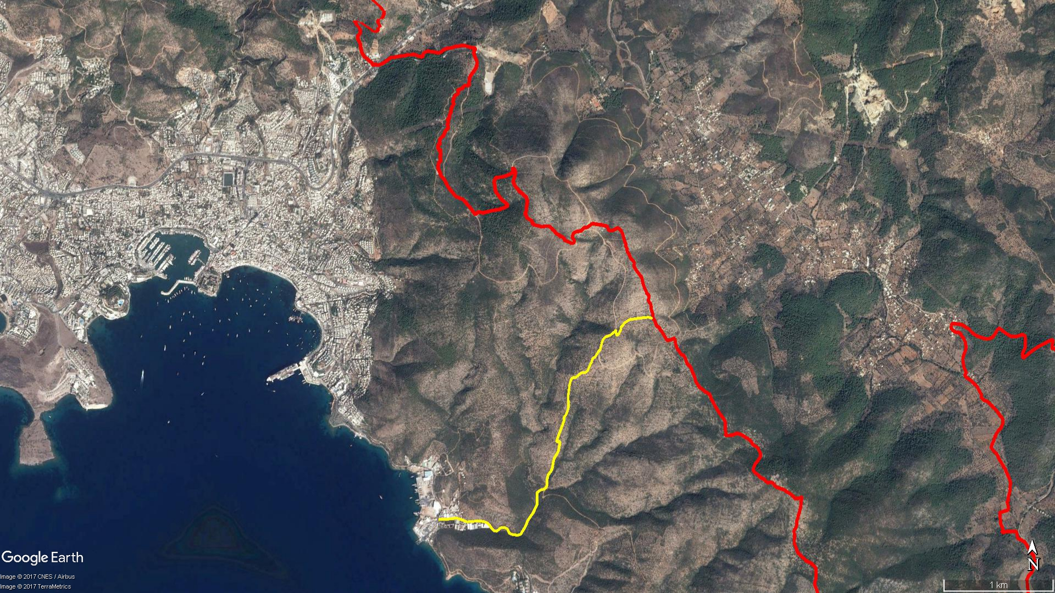
Kışladağı
İçmeler
Zeytinbeli
Pınardağı
Kamp Alanı
Cinçukuru
KIZILAĞAÇ
BODRUM
Yokuşbaşı

BOY KESİT
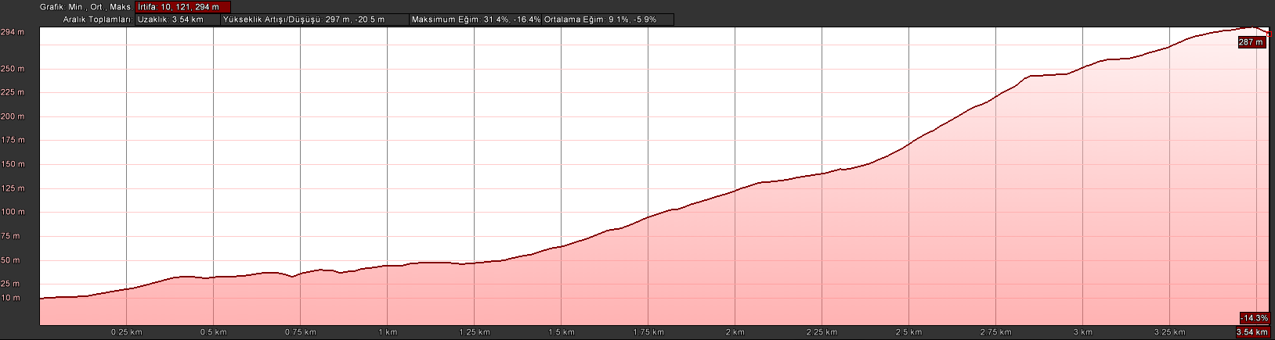
İçmeler
Zeytinbeli

KOORDİNATLAR
S.NU. | ENLEM | BOYLAM | S.NU. | ENLEM | BOYLAM
1 | 37.012526327 | 27.452672599 | 52 | 37.019858236 | 27.465170213
2 | 37.012574899 | 27.453736157 | 53 | 37.020303837 | 27.465381074
3 | 37.012648591 | 27.454575343 | 54 | 37.020590470 | 27.465497429
4 | 37.012483078 | 27.455194020 | 55 | 37.020880599 | 27.465507114
5 | 37.012345599 | 27.455631823 | 56 | 37.021086198 | 27.465710148
6 | 37.012396762 | 27.456279311 | 57 | 37.021406237 | 27.465864882
7 | 37.012429253 | 27.456925903 | 58 | 37.021665277 | 27.465957020
8 | 37.012366724 | 27.457373121 | 59 | 37.022651450 | 27.465933957
9 | 37.012248744 | 27.457685108 | 60 | 37.023617239 | 27.466091272
10 | 37.012026314 | 27.457959589 | 61 | 37.024065207 | 27.466296757
11 | 37.011806003 | 27.458141884 | 62 | 37.024133767 | 27.466749052
12 | 37.011624258 | 27.458372692 | 63 | 37.024340131 | 27.467022187
13 | 37.011592048 | 27.458644883 | 64 | 37.024499770 | 27.467318084
14 | 37.011736069 | 27.458846102 | 65 | 37.024502931 | 27.467650969
15 | 37.011909494 | 27.459124870 | 66 | 37.024654581 | 27.467911691
16 | 37.011892176 | 27.459395005 | 67 | 37.024899889 | 27.468017433
17 | 37.011809223 | 27.459665910 | 68 | 37.025096564 | 27.468139184
18 | 37.011667663 | 27.459787950 | 69 | 37.025266232 | 27.468218396
19 | 37.011442975 | 27.459910352 | 70 | 37.025330500 | 27.468313589
20 | 37.011339535 | 27.460149663 | 71 | 37.025506420 | 27.468340092
21 | 37.011307772 | 27.460395472 | 72 | 37.025668651 | 27.468434004
22 | 37.011258427 | 27.460757163 | 73 | 37.025756885 | 27.468627593
23 | 37.011348896 | 27.461071820 | 74 | 37.025890335 | 27.468765712
24 | 37.011651900 | 27.461318702 | 75 | 37.026111505 | 27.468912088
25 | 37.011966188 | 27.461548719 | 76 | 37.026234775 | 27.468996094
26 | 37.012216129 | 27.461697683 | 77 | 37.026346465 | 27.469170763
27 | 37.012401951 | 27.461753328 | 78 | 37.026703489 | 27.469285186
28 | 37.012833518 | 27.462116649 | 79 | 37.026994525 | 27.469374636
29 | 37.013078021 | 27.462339206 | 80 | 37.027243339 | 27.469509012
30 | 37.013458067 | 27.462572354 | 81 | 37.027384225 | 27.469687613
31 | 37.013818370 | 27.462774724 | 82 | 37.027475529 | 27.469962118
32 | 37.014136847 | 27.462779978 | 83 | 37.027544061 | 27.470215805
33 | 37.014499545 | 27.462730473 | 84 | 37.027698465 | 27.470439341
34 | 37.014739978 | 27.462760639 | 85 | 37.027832983 | 27.470651286
35 | 37.014927883 | 27.463068210 | 86 | 37.027962113 | 27.470738596
36 | 37.015023210 | 27.463491368 | 87 | 37.027505632 | 27.470834441
37 | 37.015169940 | 27.463674496 | 88 | 37.027633975 | 27.471035824
38 | 37.015422518 | 27.463795573 | 89 | 37.027956574 | 27.471256658
39 | 37.015732889 | 27.463754351 | 90 | 37.028230997 | 27.471306584
40 | 37.016175535 | 27.463882312 | 91 | 37.028338097 | 27.471498251
41 | 37.016449035 | 27.464148542 | 92 | 37.028495678 | 27.471569432
42 | 37.016729836 | 27.464315672 | 93 | 37.028626622 | 27.471812089
43 | 37.017149764 | 27.464382610 | 94 | 37.028800185 | 27.472162234
44 | 37.017521959 | 27.464500043 | 95 | 37.028843624 | 27.472496377
45 | 37.017846121 | 27.464740591 | 96 | 37.028882269 | 27.472821504
46 | 37.018138208 | 27.464931393 | 97 | 37.028916959 | 27.473137517
47 | 37.018486644 | 27.465014352 | 98 | 37.028929959 | 27.473362640
48 | 37.018912013 | 27.465094408 | 99 | 37.028961808 | 27.473667161
49 | 37.018873744 | 27.464725301 | 100 | 37.028985183 | 27.473937740
50 | 37.019165855 | 27.464848230 | 101 | 37.028979059 | 27.474137031
51 | 37.019490992 | 27.464986815 | 102 | 37.028879294 | 27.474490081

