İRMENE BAĞLANTI ROTASI
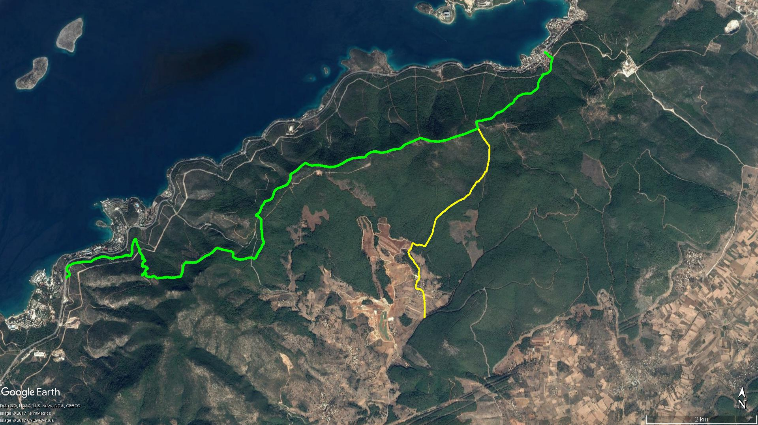
KUMKÖY
ÇAMLIK
Ardıç Dağı
TORBA
KAYNAR MEVKİİ
GÜVERCİNLİK
İRMENE

BOY KESİT
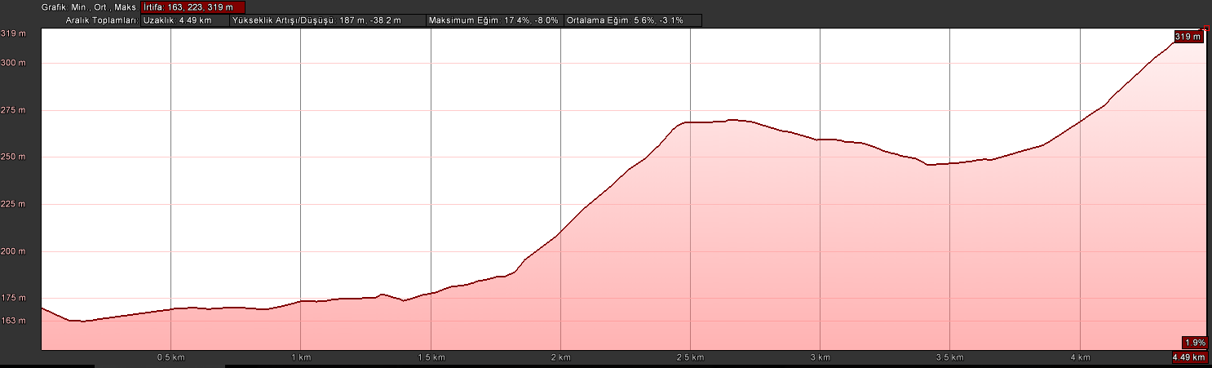
İrmene

KOORDİNATLAR
S.NU | ENLEM | BOYLAM | S.NU | ENLEM | BOYLAM
1 | 37.085391245 | 27.555791359 | 56 | 37.101887953 | 27.556943947
2 | 37.086656390 | 27.555757205 | 57 | 37.102306929 | 27.557505816
3 | 37.087785969 | 27.555616834 | 58 | 37.102821080 | 27.558058084
4 | 37.088772814 | 27.555418534 | 59 | 37.103064015 | 27.558480546
5 | 37.089319558 | 27.555271071 | 60 | 37.103490792 | 27.558953272
6 | 37.089754403 | 27.555083435 | 61 | 37.103998330 | 27.559667190
7 | 37.089969092 | 27.554616841 | 62 | 37.104409987 | 27.560395128
8 | 37.090055612 | 27.554485543 | 63 | 37.104857507 | 27.561157642
9 | 37.090052980 | 27.554326124 | 64 | 37.105140450 | 27.561836981
10 | 37.090004846 | 27.554138665 | 65 | 37.105265195 | 27.562162107
11 | 37.090109978 | 27.553690094 | 66 | 37.105536177 | 27.562477763
12 | 37.090190563 | 27.553581179 | 67 | 37.105838558 | 27.562860358
13 | 37.090321346 | 27.553566428 | 68 | 37.105911179 | 27.563082906
14 | 37.090610920 | 27.553622090 | 69 | 37.106082635 | 27.563277951
15 | 37.090932616 | 27.553684917 | 70 | 37.106252901 | 27.563380927
16 | 37.091221030 | 27.553718214 | 71 | 37.106405516 | 27.563394954
17 | 37.091589983 | 27.554067448 | 72 | 37.106817218 | 27.563607862
18 | 37.091859326 | 27.554191273 | 73 | 37.107171693 | 27.563876752
19 | 37.092140639 | 27.554231036 | 74 | 37.107475988 | 27.564051515
20 | 37.092259078 | 27.554095836 | 75 | 37.107586697 | 27.564212375
21 | 37.092372352 | 27.553977877 | 76 | 37.107809693 | 27.564342053
22 | 37.092528780 | 27.553960057 | 77 | 37.108085543 | 27.564471637
23 | 37.092749141 | 27.554028628 | 78 | 37.108174113 | 27.564643606
24 | 37.092972227 | 27.554080207 | 79 | 37.108240989 | 27.564913646
25 | 37.093264395 | 27.554051981 | 80 | 37.108615788 | 27.565283185
26 | 37.093712334 | 27.553600417 | 81 | 37.108819598 | 27.565474430
27 | 37.093887218 | 27.553481802 | 82 | 37.109101035 | 27.565720889
28 | 37.094083604 | 27.553197354 | 83 | 37.109259534 | 27.565809513
29 | 37.094404752 | 27.552887844 | 84 | 37.109440840 | 27.565956178
30 | 37.094558675 | 27.552821044 | 85 | 37.109777077 | 27.566115569
31 | 37.094838151 | 27.552552822 | 86 | 37.109918369 | 27.566236427
32 | 37.094989104 | 27.552301763 | 87 | 37.109961695 | 27.566418454
33 | 37.095379839 | 27.551852275 | 88 | 37.110354319 | 27.566493916
34 | 37.095733165 | 27.551703076 | 89 | 37.110694810 | 27.566537966
35 | 37.095899496 | 27.551609301 | 90 | 37.111062203 | 27.566585898
36 | 37.096221599 | 27.551727691 | 91 | 37.111550111 | 27.566684377
37 | 37.096559256 | 27.552119323 | 92 | 37.111858292 | 27.566736039
38 | 37.097087514 | 27.552219119 | 93 | 37.112174631 | 27.566775514
39 | 37.097410767 | 27.552337304 | 94 | 37.112497825 | 27.566745537
40 | 37.097438813 | 27.552526992 | 95 | 37.113090534 | 27.566725710
41 | 37.097296146 | 27.552859416 | 96 | 37.113552685 | 27.566687828
42 | 37.097131208 | 27.553365321 | 97 | 37.113871547 | 27.566683311
43 | 37.097280697 | 27.553702205 | 98 | 37.114021071 | 27.566667721
44 | 37.097253919 | 27.553950341 | 99 | 37.114210986 | 27.566537156
45 | 37.097224524 | 27.554345656 | 100 | 37.114384031 | 27.566333409
46 | 37.097095370 | 27.554673742 | 101 | 37.114661470 | 27.566027044
47 | 37.097135179 | 27.555015130 | 102 | 37.114935538 | 27.565718155
48 | 37.097342966 | 27.555078900 | 103 | 37.115166579 | 27.565476554
49 | 37.097917851 | 27.555473220 | 104 | 37.115382392 | 27.565232988
50 | 37.098384642 | 27.555745721 | 105 | 37.115598929 | 27.565050643
51 | 37.098971801 | 27.556092882 | 106 | 37.115876967 | 27.564859438
52 | 37.099413211 | 27.556274194 | 107 | 37.116193513 | 27.564611485
53 | 37.100288049 | 27.556405924 | 108 | 37.116500965 | 27.564371550
54 | 37.100853955 | 27.556582049 | 109 | 37.116773433 | 27.564114043
55 | 37.101419702 | 27.556672068

