KARAADA KALE VE KİLİSE ROTALARI
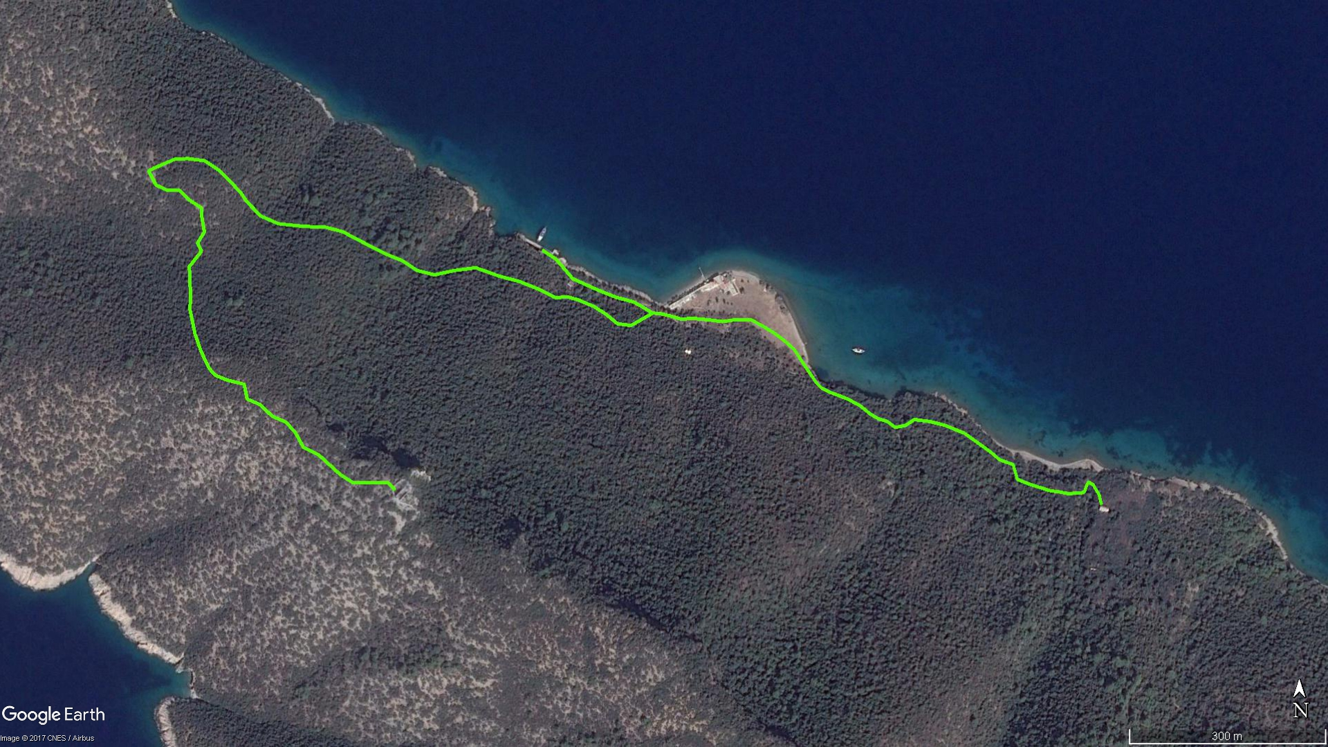
Zeytinli Tarla
Kale
Meteor Çukuru
Kilise
İskele
KARAADA KALE ROTASI BOY KESİTİ
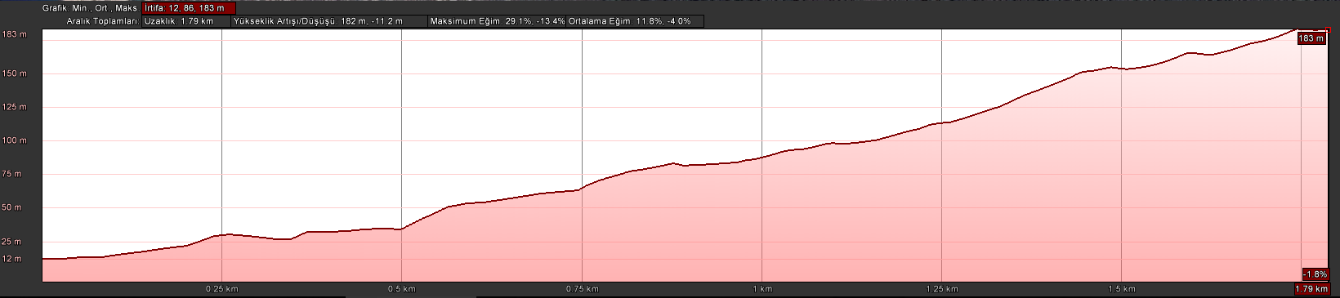
Kale
İskele
KARAADA KİLİSE ROTASI BOY KESİTİ
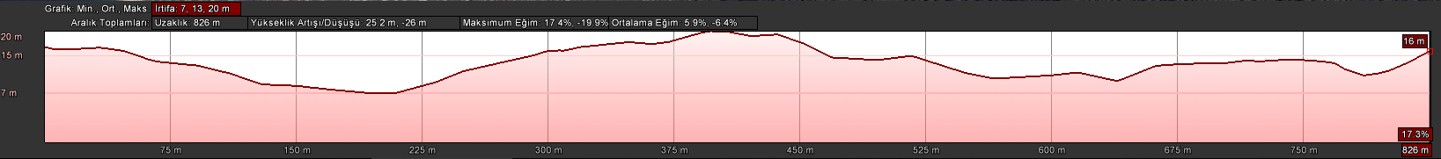
Kilise

KOORDİNATLAR
KARAADA KALE ROTASI |  |  | KARAADA KİLİSE ROTASI
SNU | ENLEM | BOYLAM | SNU | ENLEM | BOYLAM
1 | 36.986007686 | 27.450825215 | 1 | 36.985140754 | 27.452724068
2 | 36.985884113 | 27.451061715 | 2 | 36.985134709 | 27.452856869
3 | 36.985612917 | 27.451353594 | 3 | 36.985098477 | 27.453050331
4 | 36.985464189 | 27.451767366 | 4 | 36.985055716 | 27.453232166
5 | 36.985359400 | 27.452093394 | 5 | 36.985070169 | 27.453407525
6 | 36.985296032 | 27.452395523 | 6 | 36.985049236 | 27.453685697
7 | 36.985209918 | 27.452589228 | 7 | 36.985024925 | 27.453937932
8 | 36.985139652 | 27.452731680 | 8 | 36.985052275 | 27.454171311
9 | 36.984969060 | 27.452358747 | 9 | 36.985048262 | 27.454431346
10 | 36.984993255 | 27.452127495 | 10 | 36.984963892 | 27.454625673
11 | 36.985124567 | 27.451924731 | 11 | 36.984875053 | 27.454813579
12 | 36.985230172 | 27.451719576 | 12 | 36.984774428 | 27.454983729
13 | 36.985319253 | 27.451452980 | 13 | 36.984648914 | 27.455162737
14 | 36.985359739 | 27.451280301 | 14 | 36.984542375 | 27.455251615
15 | 36.985353841 | 27.451048449 | 15 | 36.984364112 | 27.455397670
16 | 36.985464176 | 27.450775835 | 16 | 36.984179598 | 27.455554427
17 | 36.985575940 | 27.450425166 | 17 | 36.984111729 | 27.455639132
18 | 36.985645825 | 27.450089851 | 18 | 36.984057402 | 27.455769498
19 | 36.985760145 | 27.449689693 | 19 | 36.984012844 | 27.455916676
20 | 36.985721219 | 27.449332554 | 20 | 36.983961356 | 27.456086786
21 | 36.985659566 | 27.448987453 | 21 | 36.983866828 | 27.456307034
22 | 36.985719826 | 27.448686143 | 22 | 36.983755634 | 27.456475052
23 | 36.985852181 | 27.448436920 | 23 | 36.983689557 | 27.456614464
24 | 36.985941788 | 27.448160418 | 24 | 36.983653716 | 27.456768158
25 | 36.986082106 | 27.447814618 | 25 | 36.983569984 | 27.456907234
26 | 36.986246300 | 27.447420752 | 26 | 36.983595140 | 27.457082209
27 | 36.986307827 | 27.447125739 | 27 | 36.983677680 | 27.457240109
28 | 36.986315627 | 27.446771278 | 28 | 36.983649543 | 27.457517281
29 | 36.986350432 | 27.446333647 | 29 | 36.983596775 | 27.457772827
30 | 36.986454774 | 27.446037401 | 30 | 36.983490837 | 27.458101633
31 | 36.986646459 | 27.445800099 | 31 | 36.983390064 | 27.458279477
32 | 36.986772078 | 27.445694159 | 32 | 36.983226167 | 27.458565519
33 | 36.986956684 | 27.445473454 | 33 | 36.983125578 | 27.458710796
34 | 36.987076400 | 27.445321830 | 34 | 36.983057668 | 27.458946121
35 | 36.987209049 | 27.445072338 | 35 | 36.982855556 | 27.459016014
36 | 36.987238285 | 27.444784637 | 36 | 36.982792445 | 27.459214644
37 | 36.987231086 | 27.444571272 | 37 | 36.982695818 | 27.459594533
38 | 36.987104588 | 27.444209694 | 38 | 36.982687104 | 27.459705670
39 | 36.987069013 | 27.444123768 | 39 | 36.982659930 | 27.459888133
40 | 36.986876962 | 27.444247263 | 40 | 36.982666340 | 27.460080983
41 | 36.986808510 | 27.444427468 | 41 | 36.982676310 | 27.460167827
42 | 36.986801338 | 27.444654291 | 42 | 36.982754061 | 27.460202965
43 | 36.986672153 | 27.444823021 | 43 | 36.982818429 | 27.460244264
44 | 36.986624971 | 27.444908675 | 44 | 36.982779728 | 27.460326317
45 | 36.986560134 | 27.445031824 | 45 | 36.982642187 | 27.460426941
46 | 36.986467711 | 27.445031843 | 46 | 36.982505514 | 27.460466784
47 | 36.986233838 | 27.445085771
48 | 36.986078535 | 27.444971256
49 | 36.985970947 | 27.445041503
50 | 36.985759717 | 27.444836379
51 | 36.985471843 | 27.444856959
52 | 36.985160809 | 27.444861795
53 | 36.984843533 | 27.444950930
54 | 36.984605161 | 27.445059364
55 | 36.984376866 | 27.445199816
56 | 36.984280211 | 27.445307211
57 | 36.984214441 | 27.445519738
58 | 36.984160821 | 27.445802432
59 | 36.983959481 | 27.445855580
60 | 36.983884475 | 27.446079223
61 | 36.983729195 | 27.446281233
62 | 36.983647529 | 27.446520767
63 | 36.983508081 | 27.446681654
64 | 36.983310028 | 27.446818600
65 | 36.983201702 | 27.447087707
66 | 36.982938608 | 27.447452428
67 | 36.982829719 | 27.447669296
68 | 36.982837650 | 27.447975175
69 | 36.982832023 | 27.448267630
70 | 36.982731330 | 27.448382491

