KARABAĞ BAĞLANTI ROTASI




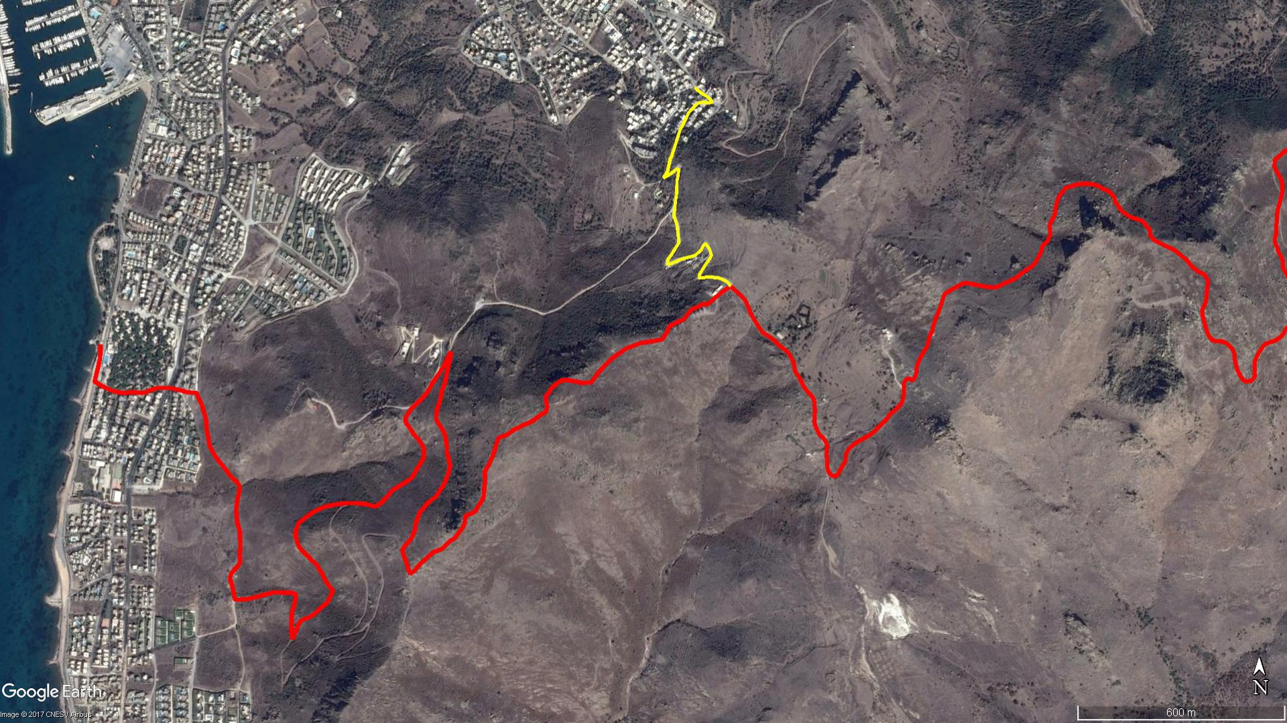
Doğru Dağı
Kızılcamandıra
Bayrak Tepe
TURGUTREİS
KARABAĞ
Sabancı Parkı

BOY KESİT
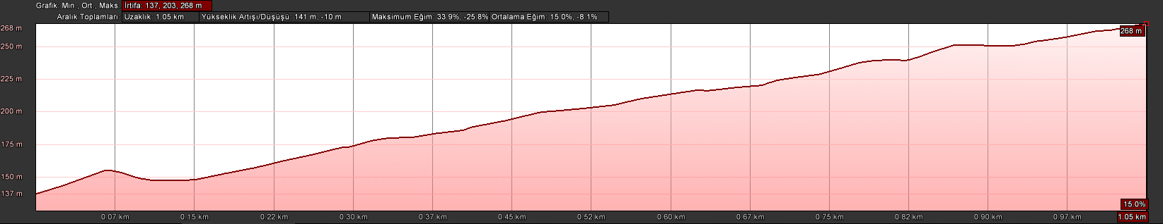
Yel Değirmenleri
Karabağ

KOORDİNATLAR
S.NU | ENLEM | BOYLAM
1 | 36.999885995 | 27.277444590
2 | 36.999746546 | 27.277639024
3 | 36.999648173 | 27.277846396
4 | 36.999503654 | 27.278019471
5 | 36.999474197 | 27.277882849
6 | 36.999502928 | 27.277721799
7 | 36.999475809 | 27.277563494
8 | 36.999376720 | 27.277421339
9 | 36.999226469 | 27.277248701
10 | 36.998997940 | 27.277113881
11 | 36.998761592 | 27.276961175
12 | 36.998398291 | 27.276819145
13 | 36.998059952 | 27.276690230
14 | 36.998048691 | 27.276663499
15 | 36.998011172 | 27.276642140
16 | 36.997700713 | 27.276564464
17 | 36.997519577 | 27.276431829
18 | 36.997611996 | 27.276637276
19 | 36.997753432 | 27.276866121
20 | 36.997726630 | 27.276927272
21 | 36.997478304 | 27.276879455
22 | 36.997471189 | 27.276878324
23 | 36.997454178 | 27.276869770
24 | 36.997101627 | 27.276851967
25 | 36.996791609 | 27.276799373
26 | 36.996517134 | 27.276770431
27 | 36.996311330 | 27.276860428
28 | 36.996008887 | 27.276903468
29 | 36.995832082 | 27.276925400
30 | 36.995562525 | 27.276717800
31 | 36.995381459 | 27.276559130
32 | 36.995257919 | 27.276573151
33 | 36.995314861 | 27.276756912
34 | 36.995394475 | 27.276968938
35 | 36.995438264 | 27.277167357
36 | 36.995481286 | 27.277381166
37 | 36.995525890 | 27.277487838
38 | 36.995636736 | 27.277640771
39 | 36.995757711 | 27.277715774
40 | 36.995793804 | 27.277800869
41 | 36.995667811 | 27.277912842
42 | 36.995496895 | 27.277982117
43 | 36.995394775 | 27.277909284
44 | 36.995259340 | 27.277786194
45 | 36.995120540 | 27.277680748
46 | 36.994991962 | 27.277579077
47 | 36.994913083 | 27.277585100
48 | 36.994924580 | 27.277720044
49 | 36.994940415 | 27.277877105
50 | 36.994928716 | 27.278044112
51 | 36.994916518 | 27.278197889
52 | 36.994864595 | 27.278366313
53 | 36.994811704 | 27.278486884
54 | 36.994692539 | 27.278600897

