KUMKÖY BAĞLANTI ROTASI
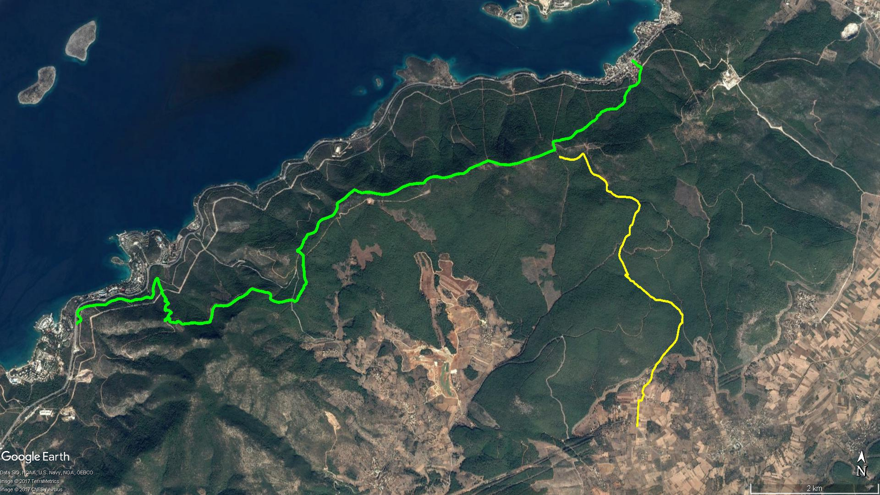
Asar Dağı
KUMKÖY
ÇAMLIK
İRMENE
GÜVERCİNLİK
Ardıç Dağı
TORBA
KAYNAR MEVKİİ

BOY KESİT
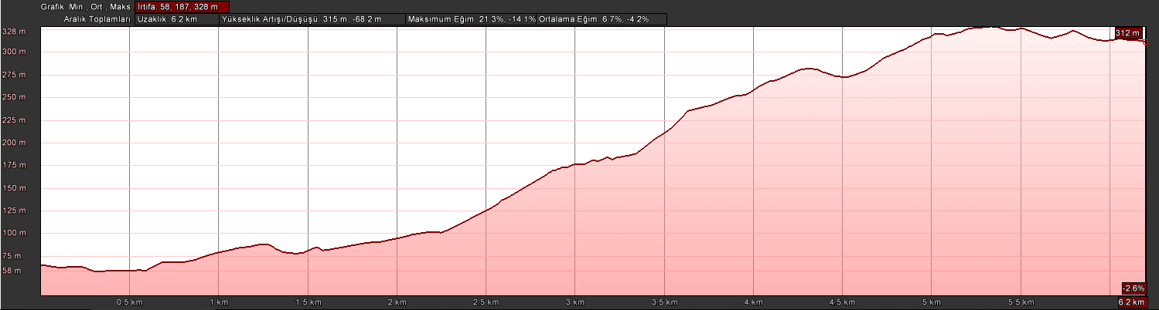
Kumköy

KOORDİNATLAR
S.NU. | ENLEM | BOYLAM | S.NU. | ENLEM | BOYLAM
1 | 37.078756746 | 27.581874478 | 59 | 37.101988090 | 27.577021353
2 | 37.080108791 | 27.581872652 | 60 | 37.102335114 | 27.576736976
3 | 37.081355304 | 27.581829613 | 61 | 37.102780624 | 27.576614483
4 | 37.082483840 | 27.581841928 | 62 | 37.103240819 | 27.576691534
5 | 37.082512706 | 27.582386041 | 63 | 37.103721749 | 27.576796958
6 | 37.083014231 | 27.582524930 | 64 | 37.104178420 | 27.577116592
7 | 37.083324563 | 27.582680246 | 65 | 37.104564718 | 27.577251686
8 | 37.083690239 | 27.582406412 | 66 | 37.105145429 | 27.577483177
9 | 37.084163739 | 27.582476551 | 67 | 37.105408969 | 27.577702025
10 | 37.084485277 | 27.582616801 | 68 | 37.105671201 | 27.578231685
11 | 37.084874693 | 27.583131808 | 69 | 37.106457017 | 27.578121241
12 | 37.085233164 | 27.583495246 | 70 | 37.106883123 | 27.578216519
13 | 37.085673338 | 27.583793949 | 71 | 37.107070740 | 27.578541167
14 | 37.086196427 | 27.583819315 | 72 | 37.107617365 | 27.578695838
15 | 37.086721574 | 27.583930623 | 73 | 37.108105514 | 27.578769731
16 | 37.087398934 | 27.584381166 | 74 | 37.108680146 | 27.578960351
17 | 37.087734041 | 27.584514196 | 75 | 37.109155075 | 27.579462949
18 | 37.088124211 | 27.584969872 | 76 | 37.109829864 | 27.579631405
19 | 37.088981925 | 27.585541665 | 77 | 37.110401237 | 27.579171915
20 | 37.089593764 | 27.586142219 | 78 | 37.110600090 | 27.578705124
21 | 37.090135379 | 27.586635662 | 79 | 37.110806083 | 27.578167274
22 | 37.090562827 | 27.587108816 | 80 | 37.110884724 | 27.577617398
23 | 37.091016387 | 27.587523044 | 81 | 37.110866697 | 27.577024432
24 | 37.091376327 | 27.587766183 | 82 | 37.110857204 | 27.576472084
25 | 37.092008706 | 27.587900888 | 83 | 37.110837514 | 27.575951012
26 | 37.092782529 | 27.587992115 | 84 | 37.110863982 | 27.575491393
27 | 37.093203343 | 27.588073591 | 85 | 37.111009090 | 27.575111169
28 | 37.093566165 | 27.588241268 | 86 | 37.111178635 | 27.574689194
29 | 37.093797248 | 27.588573793 | 87 | 37.111452281 | 27.574347833
30 | 37.094326021 | 27.588530672 | 88 | 37.111450524 | 27.574064091
31 | 37.094919341 | 27.588548447 | 89 | 37.111577671 | 27.573677449
32 | 37.095034184 | 27.588286469 | 90 | 37.111893489 | 27.573599261
33 | 37.095526435 | 27.587940226 | 91 | 37.112372147 | 27.573625456
34 | 37.095719933 | 27.587620047 | 92 | 37.112709595 | 27.573447735
35 | 37.096049681 | 27.587058703 | 93 | 37.112920271 | 27.573237167
36 | 37.096487588 | 27.586402355 | 94 | 37.113129358 | 27.572842431
37 | 37.096635140 | 27.585776129 | 95 | 37.113315873 | 27.572464313
38 | 37.096705483 | 27.584868821 | 96 | 37.113494561 | 27.572145648
39 | 37.096779412 | 27.584406244 | 97 | 37.113624922 | 27.571702449
40 | 37.096732374 | 27.583638694 | 98 | 37.113723101 | 27.571166403
41 | 37.097051587 | 27.583114630 | 99 | 37.113905843 | 27.570864469
42 | 37.097145009 | 27.582722569 | 100 | 37.114139127 | 27.570642365
43 | 37.097682395 | 27.581905048 | 101 | 37.114667696 | 27.570313496
44 | 37.098087835 | 27.581171068 | 102 | 37.115103903 | 27.570034346
45 | 37.098372292 | 27.580761688 | 103 | 37.115634602 | 27.569747736
46 | 37.098459904 | 27.580371612 | 104 | 37.116104251 | 27.569415503
47 | 37.098729373 | 27.580085805 | 105 | 37.116407397 | 27.569219008
48 | 37.098852018 | 27.579706175 | 106 | 37.116516998 | 27.569037333
49 | 37.099133094 | 27.579481297 | 107 | 37.116328256 | 27.568764486
50 | 37.099211768 | 27.578933443 | 108 | 37.115980108 | 27.568425799
51 | 37.099544735 | 27.578669619 | 109 | 37.115730671 | 27.567937787
52 | 37.099666425 | 27.578359335 | 110 | 37.115586519 | 27.567425438
53 | 37.099972888 | 27.577850148 | 111 | 37.115572524 | 27.566915278
54 | 37.099987315 | 27.578466105 | 112 | 37.115641569 | 27.566393066
55 | 37.100454720 | 27.578094071 | 113 | 37.115671498 | 27.565904749
56 | 37.100987454 | 27.577764258 | 114 | 37.115791610 | 27.565428213
57 | 37.101198181 | 27.577614994 | 115 | 37.115853518 | 27.564891752
58 | 37.101650382 | 27.577352477

