MANDRA BAĞLANTI ROTASI
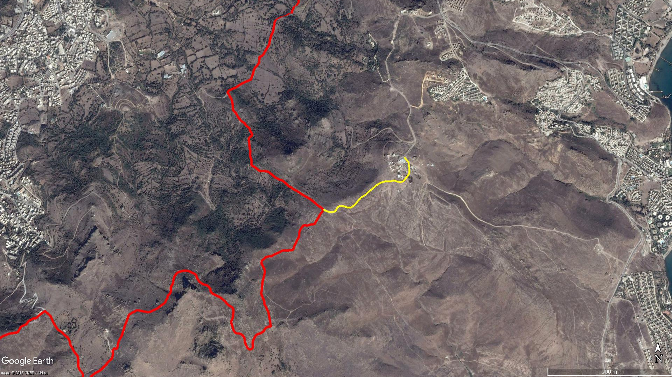
BAĞLA
Ezedin Kayalığı
KARABAĞ
AKÇAALAN
Asar Kalesi
Mandıra

BOY KESİT
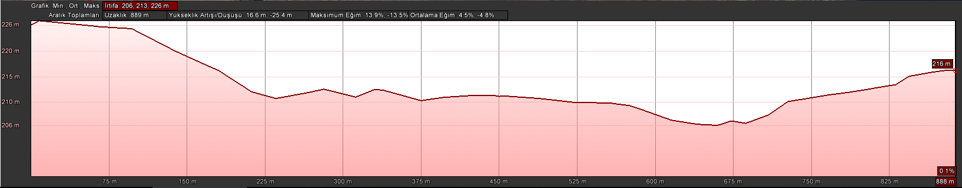
Mandıra

KOORDİNATLAR
S.NU. | ENLEM | BOYLAM
1 | 37.004680388 | 27.307703606
2 | 37.004337862 | 27.308052439
3 | 37.004126030 | 27.308076144
4 | 37.003859606 | 27.308102081
5 | 37.003638427 | 27.308106444
6 | 37.003383451 | 27.307894820
7 | 37.003111269 | 27.307609939
8 | 37.003057346 | 27.307353544
9 | 37.003132179 | 27.307015353
10 | 37.003172065 | 27.306857341
11 | 37.003105355 | 27.306528943
12 | 37.003126839 | 27.306220722
13 | 37.003034136 | 27.305809800
14 | 37.002952901 | 27.305619977
15 | 37.002796735 | 27.305344811
16 | 37.002618364 | 27.305094926
17 | 37.002444610 | 27.304816044
18 | 37.002236716 | 27.304552738
19 | 37.002076657 | 27.304207468
20 | 37.001884952 | 27.303990292
21 | 37.001674980 | 27.303782274
22 | 37.001522039 | 27.303574954
23 | 37.001422627 | 27.303387721
24 | 37.001419254 | 27.303090373
25 | 37.001480955 | 27.302862169
26 | 37.001512979 | 27.302634391
27 | 37.001512891 | 27.302430019
28 | 37.001389310 | 27.302255936
29 | 37.001236815 | 27.302163782
30 | 37.001141164 | 27.302040889
31 | 37.001108776 | 27.301810050
32 | 37.001131889 | 27.301553158
33 | 37.001202949 | 27.301332624
34 | 37.001295468 | 27.301117055

