ORTAKENT BİTEZ ROTASI
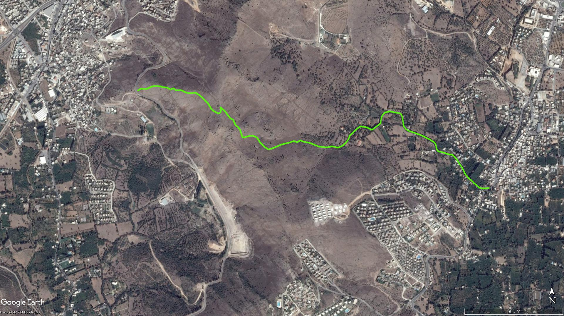
Mandıra Tepe
Okul
BİTEZ
ORTAKENT

BOY KESİT
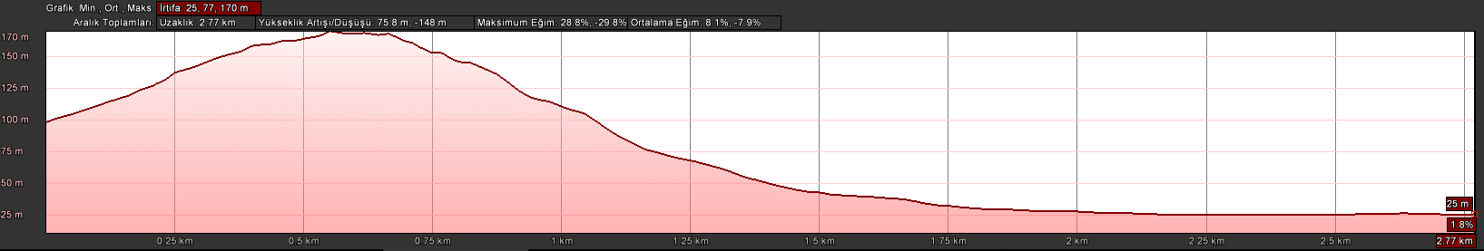
Bitez
Yel Değirmenleri

KOORDİNATLAR
S.NU | ENLEM | BOYLAM | S.NU | ENLEM | BOYLAM
1 | 37.046829142 | 27.354031001 | 63 | 37.043982383 | 27.365782495
2 | 37.046936425 | 27.354287849 | 64 | 37.043844468 | 27.366213088
3 | 37.046915725 | 27.354648259 | 65 | 37.043777361 | 27.366426731
4 | 37.047015565 | 27.354908912 | 66 | 37.043751593 | 27.366790795
5 | 37.047072152 | 27.355124577 | 67 | 37.043744580 | 27.366980766
6 | 37.047081821 | 27.355256020 | 68 | 37.043795561 | 27.367319389
7 | 37.047063899 | 27.355622133 | 69 | 37.043724715 | 27.367693597
8 | 37.047014527 | 27.355773616 | 70 | 37.043782846 | 27.367894642
9 | 37.046999833 | 27.356054130 | 71 | 37.043876834 | 27.368106698
10 | 37.046879843 | 27.356295294 | 72 | 37.044014002 | 27.368272003
11 | 37.046953104 | 27.356488670 | 73 | 37.044217198 | 27.368449510
12 | 37.046853043 | 27.356651016 | 74 | 37.044380394 | 27.368502253
13 | 37.046840182 | 27.357086941 | 75 | 37.044528603 | 27.368713078
14 | 37.046762937 | 27.357230686 | 76 | 37.044614959 | 27.368810475
15 | 37.046699842 | 27.357433120 | 77 | 37.044782200 | 27.369046973
16 | 37.046681753 | 27.357723046 | 78 | 37.044888613 | 27.369232803
17 | 37.046710626 | 27.358000431 | 79 | 37.044867916 | 27.369478126
18 | 37.046582835 | 27.358262691 | 80 | 37.044829794 | 27.369701628
19 | 37.046443932 | 27.358460632 | 81 | 37.044702519 | 27.370033364
20 | 37.046222943 | 27.358730826 | 82 | 37.044881135 | 27.370339811
21 | 37.046135086 | 27.358851873 | 83 | 37.045055822 | 27.370622862
22 | 37.045992284 | 27.358959163 | 84 | 37.045381419 | 27.370681432
23 | 37.045785143 | 27.359122310 | 85 | 37.045545149 | 27.370793196
24 | 37.045726003 | 27.359210316 | 86 | 37.045659002 | 27.370943864
25 | 37.045678984 | 27.359316383 | 87 | 37.045715298 | 27.371286104
26 | 37.045582674 | 27.359548954 | 88 | 37.045655845 | 27.371602471
27 | 37.045593034 | 27.359636399 | 89 | 37.045614944 | 27.371931979
28 | 37.045677724 | 27.359726806 | 90 | 37.045537570 | 27.372055279
29 | 37.045777736 | 27.359755793 | 91 | 37.045346707 | 27.372127604
30 | 37.045924203 | 27.359697011 | 92 | 37.045105852 | 27.372174694
31 | 37.045847746 | 27.359789091 | 93 | 37.044889640 | 27.372215828
32 | 37.045745453 | 27.359953227 | 94 | 37.044734451 | 27.372376954
33 | 37.045624582 | 27.360080778 | 95 | 37.044633984 | 27.372580555
34 | 37.045490529 | 27.360202256 | 96 | 37.044555243 | 27.372903163
35 | 37.045298419 | 27.360386219 | 97 | 37.044476969 | 27.373157621
36 | 37.045237837 | 27.360567372 | 98 | 37.044390698 | 27.373458849
37 | 37.045034454 | 27.360672052 | 99 | 37.044261977 | 27.373768368
38 | 37.044927239 | 27.360747760 | 100 | 37.044152520 | 27.374038757
39 | 37.044850352 | 27.360877078 | 101 | 37.044008992 | 27.374321455
40 | 37.044713310 | 27.361022511 | 102 | 37.043890867 | 27.374409050
41 | 37.044585279 | 27.361075399 | 103 | 37.043711647 | 27.374452181
42 | 37.044411906 | 27.361140107 | 104 | 37.043598522 | 27.374494389
43 | 37.044272026 | 27.361210624 | 105 | 37.043517487 | 27.374591883
44 | 37.044298110 | 27.361421699 | 106 | 37.043491990 | 27.374763607
45 | 37.044362988 | 27.361661170 | 107 | 37.043440878 | 27.375000277
46 | 37.044365628 | 27.361911445 | 108 | 37.043383476 | 27.375183902
47 | 37.044279767 | 27.362162295 | 109 | 37.043346533 | 27.375382870
48 | 37.044150189 | 27.362280974 | 110 | 37.043333101 | 27.375556790
49 | 37.044010825 | 27.362380607 | 111 | 37.043188911 | 27.375727960
50 | 37.043860675 | 27.362567990 | 112 | 37.043058834 | 27.375866208
51 | 37.043743475 | 27.362729030 | 113 | 37.042846937 | 27.376022449
52 | 37.043621857 | 27.362954666 | 114 | 37.042689704 | 27.376167287
53 | 37.043663941 | 27.363152208 | 115 | 37.042510066 | 27.376295247
54 | 37.043783252 | 27.363531125 | 116 | 37.042288513 | 27.376417917
55 | 37.043880395 | 27.363798319 | 117 | 37.042037556 | 27.376666436
56 | 37.043943263 | 27.364070637 | 118 | 37.041906126 | 27.376878556
57 | 37.043999883 | 27.364394423 | 119 | 37.041781774 | 27.377029460
58 | 37.044087209 | 27.364675679 | 120 | 37.041653054 | 27.377213103
59 | 37.044015024 | 27.364906125 | 121 | 37.041541298 | 27.377378279
60 | 37.044123540 | 27.365136709 | 122 | 37.041491061 | 27.377573143
61 | 37.044051273 | 27.365340818 | 123 | 37.041492293 | 27.377775654
62 | 37.044014540 | 27.365573625 | 124 | 37.041513369 | 27.378079982

