ORTAKENT YAKA ROTASI
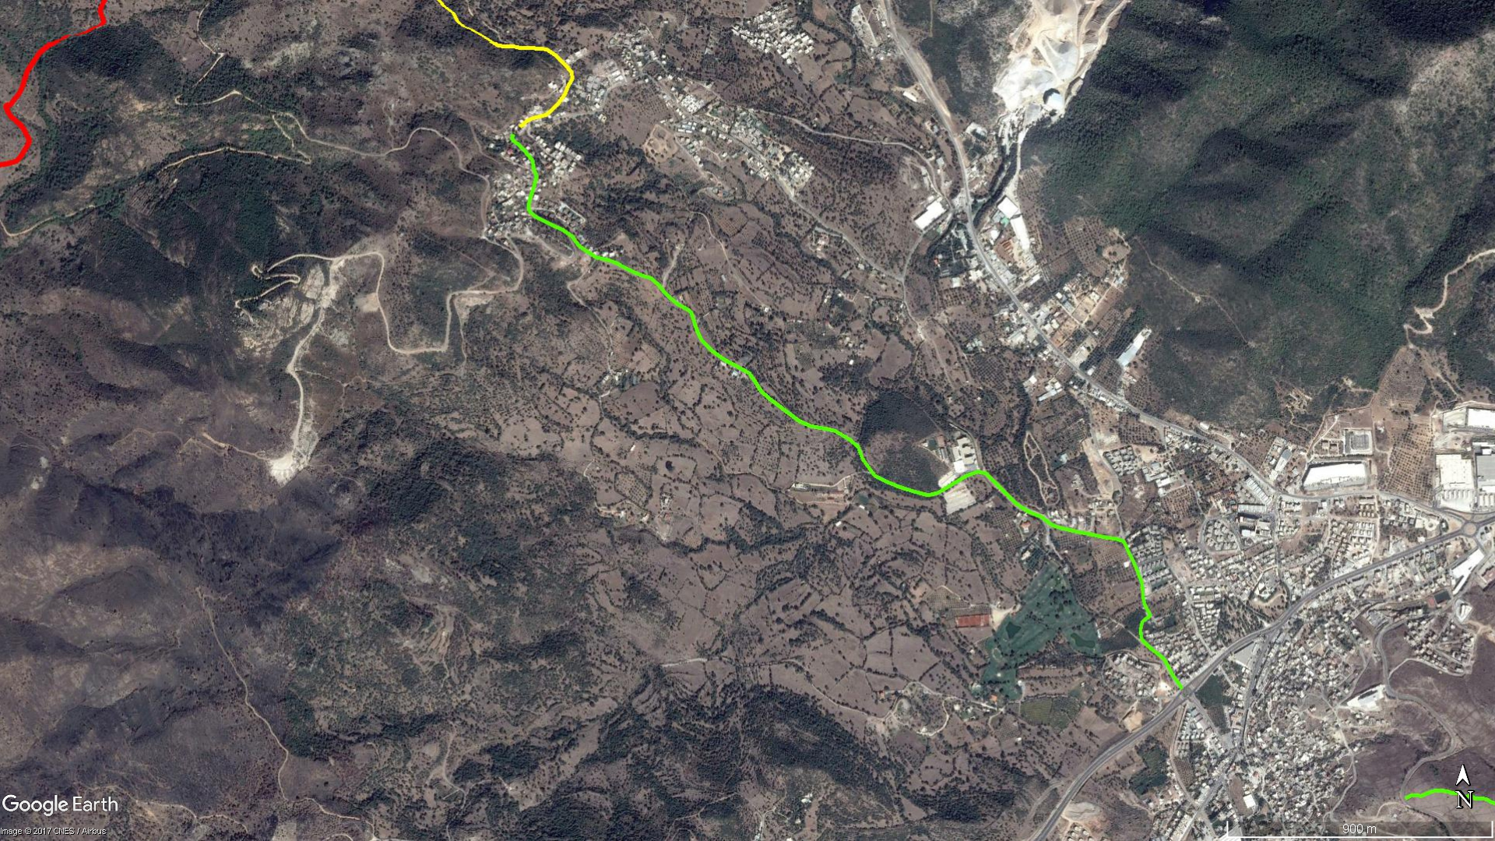
YAKAKÖY
Okul
ORTAKENT

BOY KESİT
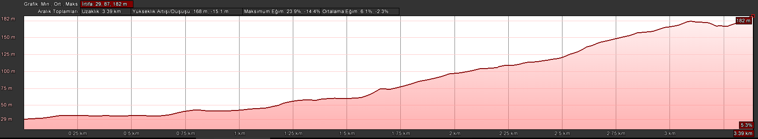
Yakaköy
Ortakent

KOORDİNATLAR
S.NU | ENLEM | BOYLAM
1 | 37.050169261 | 27.345520271
2 | 37.050616669 | 27.345127468
3 | 37.051079488 | 27.344826614
4 | 37.051405754 | 27.344312018
5 | 37.051691856 | 27.343946273
6 | 37.051969302 | 27.343905079
7 | 37.052225248 | 27.343969752
8 | 37.052427832 | 27.344291144
9 | 37.052725974 | 27.344079740
10 | 37.052963977 | 27.344006496
11 | 37.053413918 | 27.343964860
12 | 37.053837513 | 27.343757230
13 | 37.054074352 | 27.343632516
14 | 37.054365788 | 27.343451700
15 | 37.054701847 | 27.343257758
16 | 37.054772972 | 27.342968367
17 | 37.054820474 | 27.342522076
18 | 37.054909570 | 27.342009918
19 | 37.055020653 | 27.341298397
20 | 37.055115227 | 27.340792721
21 | 37.055201602 | 27.340478907
22 | 37.055451128 | 27.340085914
23 | 37.055613314 | 27.339582163
24 | 37.055846019 | 27.339126115
25 | 37.056330668 | 27.338521154
26 | 37.056783406 | 27.337957775
27 | 37.056836358 | 27.337632340
28 | 37.056714174 | 27.337199430
29 | 37.056515546 | 27.336787144
30 | 37.056365806 | 27.336462753
31 | 37.056179326 | 27.336074150
32 | 37.056114584 | 27.335716763
33 | 37.056225540 | 27.335180667
34 | 37.056383549 | 27.334564526
35 | 37.056527803 | 27.334124280
36 | 37.056714589 | 27.333664879
37 | 37.056923564 | 27.333470054
38 | 37.057230717 | 27.333192475
39 | 37.057601723 | 27.333027733
40 | 37.057832326 | 27.332686054
41 | 37.058091249 | 27.332121248
42 | 37.058145028 | 27.331836373
43 | 37.058226290 | 27.331235246
44 | 37.058379149 | 27.330781103
45 | 37.058668481 | 27.330287033
46 | 37.059033005 | 27.329680977
47 | 37.059284056 | 27.329308691
48 | 37.059651674 | 27.329016891
49 | 37.059862054 | 27.328821944
50 | 37.060028123 | 27.328442328
51 | 37.060273426 | 27.327866900
52 | 37.060535690 | 27.327412405
53 | 37.060829916 | 27.327035577
54 | 37.061123444 | 27.326848274
55 | 37.061499624 | 27.326694804
56 | 37.061671631 | 27.326625755
57 | 37.061775887 | 27.326523777
58 | 37.061985381 | 27.326050344
59 | 37.062262407 | 27.325660413
60 | 37.062555892 | 27.325350418
61 | 37.062760220 | 27.325062022
62 | 37.062835316 | 27.324728897
63 | 37.063008752 | 27.324220543
64 | 37.063212637 | 27.323752701
65 | 37.063311488 | 27.323426708
66 | 37.063388652 | 27.322969205
67 | 37.063589100 | 27.322583051
68 | 37.063750104 | 27.322295900
69 | 37.064016697 | 27.322066014
70 | 37.064223168 | 27.321704210
71 | 37.064342058 | 27.321359149
72 | 37.064500044 | 27.320967869
73 | 37.064598708 | 27.320716449
74 | 37.064700104 | 27.320532347
75 | 37.064861918 | 27.320380541
76 | 37.065086189 | 27.320412416
77 | 37.065390023 | 27.320533138
78 | 37.065601186 | 27.320606701
79 | 37.065852967 | 27.320691640
80 | 37.066092797 | 27.320583019
81 | 37.066337993 | 27.320536881
82 | 37.066541648 | 27.320337015
83 | 37.066774039 | 27.320075030
84 | 37.066877811 | 27.319910759
85 | 37.066963584 | 27.319778305
86 | 37.067028402 | 27.319744334
87 | 37.067136284 | 27.319803107

