TORBA BAĞLANTI ROTASI
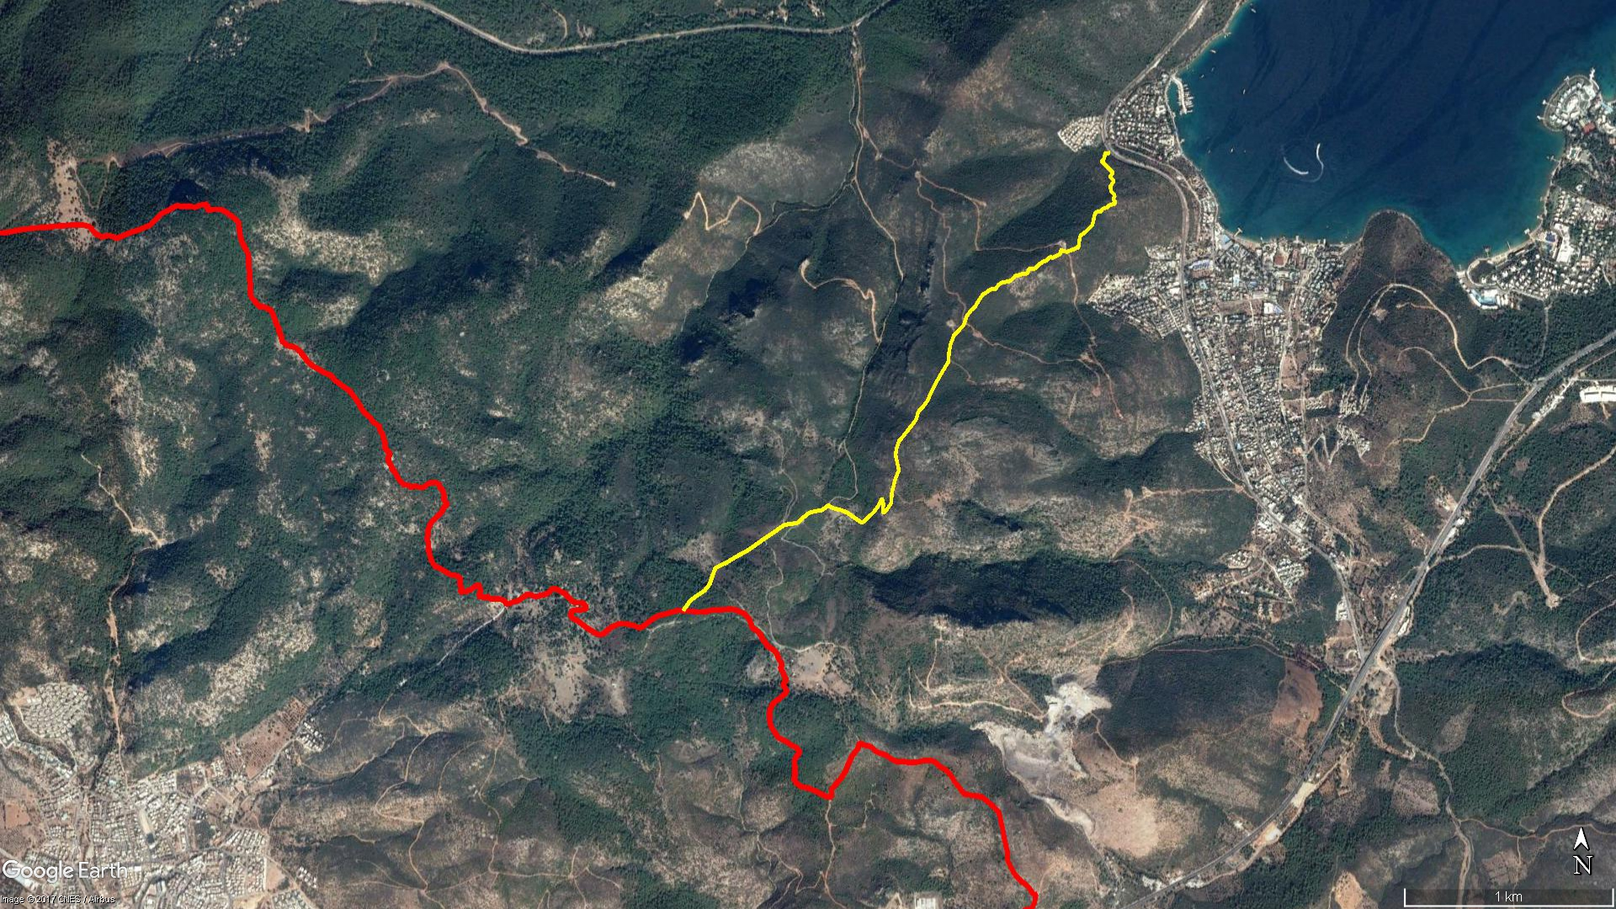
Gebe Kilise
TORBA
Pedasa
Kamp Alanı
Çukursarnıç
Pedasa
KONACIK

BOY KESİT
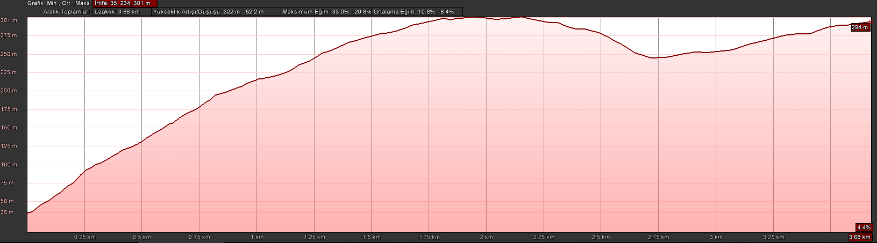
Torba
Pedasa

KOORDİNATLAR
S.NU | ENLEM | BOYLAM | S.NU | ENLEM | BOYLAM
1 | 37.085581924 | 27.451364203 | 67 | 37.079472147 | 27.444473313
2 | 37.085564334 | 27.451106488 | 68 | 37.079289881 | 27.444310236
3 | 37.085330047 | 27.451047892 | 69 | 37.079147962 | 27.444199548
4 | 37.085202257 | 27.450908667 | 70 | 37.078931162 | 27.444044218
5 | 37.085104580 | 27.451040342 | 71 | 37.078783184 | 27.443820844
6 | 37.084976202 | 27.451212991 | 72 | 37.078555879 | 27.443608693
7 | 37.084848949 | 27.451346237 | 73 | 37.078141349 | 27.443420071
8 | 37.084739130 | 27.451529044 | 74 | 37.077708469 | 27.442901803
9 | 37.084549578 | 27.451339971 | 75 | 37.077343928 | 27.442734024
10 | 37.084367956 | 27.451559094 | 76 | 37.076997839 | 27.442649466
11 | 37.084119771 | 27.451360533 | 77 | 37.076589837 | 27.442610883
12 | 37.083922947 | 27.451394774 | 78 | 37.076145295 | 27.442272533
13 | 37.083741098 | 27.451605569 | 79 | 37.075626462 | 27.441894588
14 | 37.083598388 | 27.451509726 | 80 | 37.075283382 | 27.441678758
15 | 37.083480057 | 27.451595700 | 81 | 37.074921078 | 27.441486341
16 | 37.083375915 | 27.451586285 | 82 | 37.074666563 | 27.441246074
17 | 37.083328927 | 27.451319028 | 83 | 37.074457481 | 27.440999361
18 | 37.083221459 | 27.451165088 | 84 | 37.074116247 | 27.440878808
19 | 37.083155502 | 27.450913725 | 85 | 37.073746168 | 27.440516352
20 | 37.083033581 | 27.450850305 | 86 | 37.073442351 | 27.440217030
21 | 37.083028677 | 27.450623850 | 87 | 37.073202228 | 27.439957356
22 | 37.082976361 | 27.450525021 | 88 | 37.072848449 | 27.439824415
23 | 37.082831380 | 27.450476455 | 89 | 37.072617117 | 27.439788901
24 | 37.082615447 | 27.450426267 | 90 | 37.072238983 | 27.439888185
25 | 37.082452472 | 27.450362104 | 91 | 37.071965497 | 27.439961764
26 | 37.082347660 | 27.450232076 | 92 | 37.071653422 | 27.439796762
27 | 37.082140917 | 27.449970267 | 93 | 37.071205897 | 27.439641131
28 | 37.082001009 | 27.449724228 | 94 | 37.070972095 | 27.439581064
29 | 37.081773733 | 27.449660958 | 95 | 37.070588792 | 27.439562704
30 | 37.081499103 | 27.449616046 | 96 | 37.070340417 | 27.439361668
31 | 37.081401391 | 27.449307865 | 97 | 37.070128750 | 27.439141628
32 | 37.081306178 | 27.448984261 | 98 | 37.070236404 | 27.439106474
33 | 37.081316556 | 27.448889402 | 99 | 37.070552461 | 27.439139625
34 | 37.081333426 | 27.448790601 | 100 | 37.070775724 | 27.439060825
35 | 37.081373931 | 27.448703898 | 101 | 37.070452968 | 27.438870468
36 | 37.081360548 | 27.448652900 | 102 | 37.070167720 | 27.438603450
37 | 37.081248428 | 27.448642148 | 103 | 37.069726893 | 27.438009604
38 | 37.081176069 | 27.448557690 | 104 | 37.069938756 | 27.437589673
39 | 37.081121895 | 27.448415748 | 105 | 37.070137297 | 27.437256575
40 | 37.081071402 | 27.448295243 | 106 | 37.070256036 | 27.436924244
41 | 37.081050140 | 27.448201956 | 107 | 37.070317795 | 27.436595574
42 | 37.081073037 | 27.448104338 | 108 | 37.070363535 | 27.436408055
43 | 37.081046336 | 27.448045353 | 109 | 37.070470575 | 27.436196148
44 | 37.080972330 | 27.447949681 | 110 | 37.070270426 | 27.435866457
45 | 37.080893315 | 27.447812955 | 111 | 37.070190420 | 27.435326885
46 | 37.080875653 | 27.447673374 | 112 | 37.070117908 | 27.435105800
47 | 37.080818250 | 27.447609719 | 113 | 37.069902335 | 27.434782284
48 | 37.080769516 | 27.447509000 | 114 | 37.069719700 | 27.434548811
49 | 37.080695001 | 27.447409732 | 115 | 37.069645892 | 27.433886392
50 | 37.080580563 | 27.447275099 | 116 | 37.069524541 | 27.433629172
51 | 37.080556469 | 27.446940071 | 117 | 37.069322829 | 27.433293611
52 | 37.080476748 | 27.446916563 | 118 | 37.069035877 | 27.432749271
53 | 37.080394093 | 27.446868238 | 119 | 37.068721203 | 27.432190768
54 | 37.080341210 | 27.446738242 | 120 | 37.068492901 | 27.431766018
55 | 37.080362586 | 27.446671342 | 121 | 37.068296188 | 27.431291877
56 | 37.080346652 | 27.446565214 | 122 | 37.068034224 | 27.430763481
57 | 37.080268580 | 27.446301567 | 123 | 37.067858497 | 27.430299649
58 | 37.080267183 | 27.446213260 | 124 | 37.067814265 | 27.430166425
59 | 37.080095232 | 27.446006347 | 125 | 37.067480178 | 27.430007920
60 | 37.080009035 | 27.445831331 | 126 | 37.067109334 | 27.429853095
61 | 37.080008282 | 27.445570109 | 127 | 37.066839809 | 27.429583878
62 | 37.079886346 | 27.445317687 | 128 | 37.066624164 | 27.429163692
63 | 37.079701559 | 27.445148321 | 129 | 37.066415307 | 27.428815705
64 | 37.079694301 | 27.444947873 | 130 | 37.066180249 | 27.428613064
65 | 37.079633749 | 27.444781002 | 131 | 37.065984565 | 27.428427871
66 | 37.079524921 | 27.444608191

