YALIKAVAK BAĞLANTI ROTASI
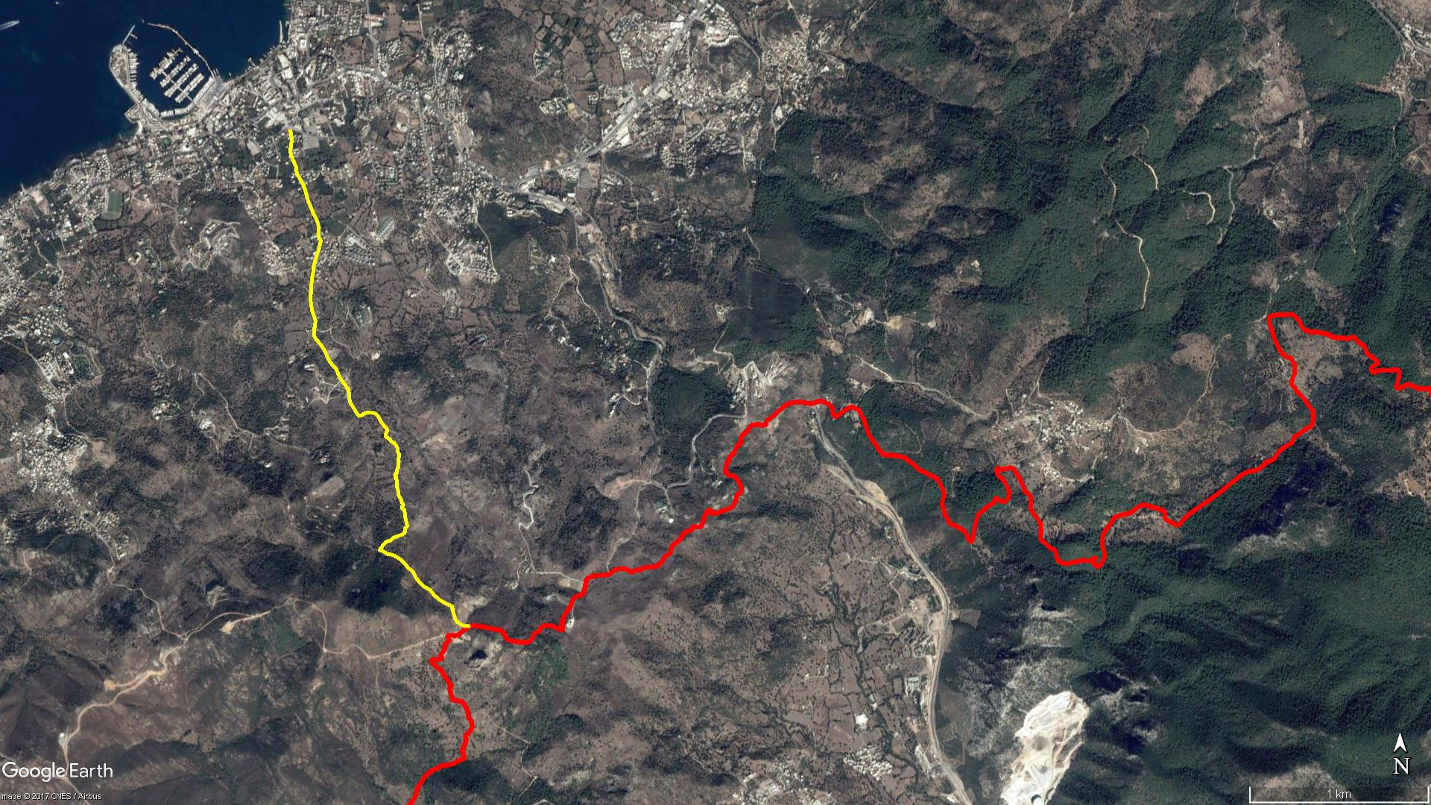
GERİŞ
YALIKAVAK
Çobanyurdu
Kamp Alanı
Partipalas
Sandıma
DAĞBELEN

BOY KESİT
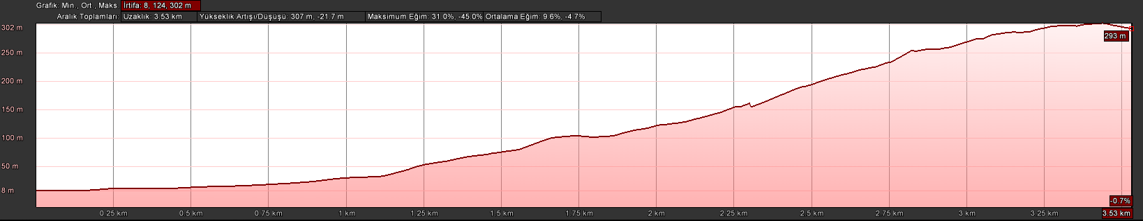
Partipalas
Yalıkavak

KOORDİNATLAR
1 | 37.102397854 | 27.292984567 | 90 | 37.085948276 | 27.299931454
2 | 37.102150937 | 27.293025830 | 91 | 37.085911705 | 27.299976351
3 | 37.101949305 | 27.293078533 | 92 | 37.085774806 | 27.299967606
4 | 37.101654962 | 27.293044528 | 93 | 37.085689447 | 27.299954461
5 | 37.101320001 | 27.292973848 | 94 | 37.085579836 | 27.299930606
6 | 37.101082580 | 27.293038303 | 95 | 37.085481719 | 27.299933217
7 | 37.100816595 | 27.293178348 | 96 | 37.085285638 | 27.299956055
8 | 37.100615001 | 27.293286467 | 97 | 37.085128730 | 27.299862073
9 | 37.100436660 | 27.293375142 | 98 | 37.085033610 | 27.299871468
10 | 37.100171884 | 27.293393586 | 99 | 37.084893834 | 27.299840484
11 | 37.099921041 | 27.293577200 | 100 | 37.084911918 | 27.299708809
12 | 37.099609410 | 27.293802253 | 101 | 37.084761488 | 27.299796727
13 | 37.099315804 | 27.293937512 | 102 | 37.084692459 | 27.299756832
14 | 37.099006192 | 27.294040526 | 103 | 37.084555659 | 27.299857623
15 | 37.098720011 | 27.294142526 | 104 | 37.084384205 | 27.299882856
16 | 37.098297420 | 27.294369569 | 105 | 37.084234412 | 27.299852061
17 | 37.098041099 | 27.294513171 | 106 | 37.084090007 | 27.299928798
18 | 37.097820566 | 27.294651384 | 107 | 37.083841702 | 27.299950107
19 | 37.097606020 | 27.294759024 | 108 | 37.083645846 | 27.300112735
20 | 37.097356945 | 27.294796645 | 109 | 37.083448259 | 27.300177479
21 | 37.097105881 | 27.294765702 | 110 | 37.083355838 | 27.300290085
22 | 37.096945070 | 27.294803420 | 111 | 37.083256768 | 27.300246700
23 | 37.096711706 | 27.294932693 | 112 | 37.083206494 | 27.300148839
24 | 37.096304327 | 27.294817297 | 113 | 37.083090863 | 27.300350263
25 | 37.096101571 | 27.294714505 | 114 | 37.082874246 | 27.300389947
26 | 37.095729378 | 27.294580988 | 115 | 37.082659648 | 27.300425271
27 | 37.095399198 | 27.294461608 | 116 | 37.082388164 | 27.300510721
28 | 37.095102835 | 27.294439704 | 117 | 37.082240053 | 27.300542828
29 | 37.094856822 | 27.294381871 | 118 | 37.082176082 | 27.300411305
30 | 37.094570062 | 27.294343584 | 119 | 37.082014039 | 27.300411800
31 | 37.094314309 | 27.294326552 | 120 | 37.081935465 | 27.300386766
32 | 37.093990365 | 27.294297955 | 121 | 37.081872064 | 27.300299558
33 | 37.093712545 | 27.294288765 | 122 | 37.081825755 | 27.300200653
34 | 37.093461567 | 27.294331345 | 123 | 37.081790670 | 27.300047061
35 | 37.093182151 | 27.294387601 | 124 | 37.081748303 | 27.299915463
36 | 37.092913740 | 27.294508781 | 125 | 37.081694518 | 27.299703826
37 | 37.092670516 | 27.294606713 | 126 | 37.081600332 | 27.299575063
38 | 37.092217171 | 27.294525250 | 127 | 37.081525609 | 27.299431849
39 | 37.091969437 | 27.294500851 | 128 | 37.081483139 | 27.299244622
40 | 37.091770393 | 27.294605768 | 129 | 37.081388820 | 27.299109764
41 | 37.091622084 | 27.294773526 | 130 | 37.081275099 | 27.298994288
42 | 37.091420144 | 27.294978168 | 131 | 37.081040050 | 27.298783524
43 | 37.091202076 | 27.295168787 | 132 | 37.081028753 | 27.298969959
44 | 37.091020718 | 27.295284541 | 133 | 37.080972175 | 27.299096856
45 | 37.090791146 | 27.295401333 | 134 | 37.080893569 | 27.299231054
46 | 37.090618992 | 27.295513047 | 135 | 37.080861473 | 27.299324361
47 | 37.090457558 | 27.295660883 | 136 | 37.080846281 | 27.299435300
48 | 37.090325642 | 27.295809666 | 137 | 37.080828231 | 27.299583367
49 | 37.090219998 | 27.295944850 | 138 | 37.080787381 | 27.299726349
50 | 37.089952624 | 27.296074302 | 139 | 37.080708954 | 27.299868884
51 | 37.089740277 | 27.296213929 | 140 | 37.080648491 | 27.300036032
52 | 37.089544125 | 27.296372886 | 141 | 37.080536873 | 27.300210031
53 | 37.089396216 | 27.296545431 | 142 | 37.080420031 | 27.300369151
54 | 37.089193116 | 27.296682069 | 143 | 37.080269137 | 27.300528283
55 | 37.089038104 | 27.296756632 | 144 | 37.080098790 | 27.300730209
56 | 37.088859475 | 27.296785170 | 145 | 37.080046440 | 27.300823405
57 | 37.088623376 | 27.296813896 | 146 | 37.079982930 | 27.300935100
58 | 37.088496769 | 27.296855997 | 147 | 37.079916724 | 27.300980349
59 | 37.088386826 | 27.296944051 | 148 | 37.079762011 | 27.301071579
60 | 37.088217992 | 27.297088172 | 149 | 37.079618784 | 27.301183705
61 | 37.087998163 | 27.297262167 | 150 | 37.079484969 | 27.301312926
62 | 37.087864927 | 27.297368598 | 151 | 37.079371611 | 27.301435640
63 | 37.087828807 | 27.297443955 | 152 | 37.079270914 | 27.301569046
64 | 37.087848292 | 27.297566792 | 153 | 37.079165241 | 27.301783076
65 | 37.087959653 | 27.297760743 | 154 | 37.079109590 | 27.301901847
66 | 37.087997232 | 27.297911087 | 155 | 37.079040969 | 27.302041215
67 | 37.087994844 | 27.298089317 | 156 | 37.078952106 | 27.302127343
68 | 37.087977998 | 27.298328688 | 157 | 37.078815601 | 27.302256906
69 | 37.087932218 | 27.298502218 | 158 | 37.078714672 | 27.302401062
70 | 37.087847704 | 27.298612318 | 159 | 37.078612710 | 27.302534332
71 | 37.087686539 | 27.298722734 | 160 | 37.078534427 | 27.302686362
72 | 37.087536746 | 27.298829736 | 161 | 37.078450681 | 27.302864312
73 | 37.087360072 | 27.298982729 | 162 | 37.078380408 | 27.303033770
74 | 37.087245771 | 27.299113532 | 163 | 37.078308282 | 27.303216713
75 | 37.087168077 | 27.299206197 | 164 | 37.078278847 | 27.303336471
76 | 37.087081586 | 27.299223354 | 165 | 37.078244802 | 27.303410656
77 | 37.086985058 | 27.299167913 | 166 | 37.078139138 | 27.303436114
78 | 37.086889390 | 27.299102835 | 167 | 37.078041411 | 27.303448303
79 | 37.086813579 | 27.299110968 | 168 | 37.077942398 | 27.303488912
80 | 37.086733997 | 27.299214363 | 169 | 37.077772644 | 27.303556426
81 | 37.086668863 | 27.299349069 | 170 | 37.077634326 | 27.303598874
82 | 37.086595498 | 27.299441028 | 171 | 37.077532210 | 27.303661918
83 | 37.086527100 | 27.299514895 | 172 | 37.077434949 | 27.303768138
84 | 37.086489412 | 27.299590712 | 173 | 37.077345809 | 27.303920175
85 | 37.086461326 | 27.299663904 | 174 | 37.077288265 | 27.304050885
86 | 37.086379753 | 27.299736331 | 175 | 37.077254464 | 27.304172337
87 | 37.086300354 | 27.299815220 | 176 | 37.077240900 | 27.304290571
88 | 37.086202691 | 27.299868620 | 177 | 37.077228475 | 27.304428415
89 | 37.086059599 | 27.299888492 | 178 | 37.077223637 | 27.304558235

